Bernice Templeman

CIS 5740/ Spring 2016

Final Project

Project: Transactional Website

For this project, you’ll enhance the application described in the previous Music Store programs ( 4 & 5) by adding it to the admin section of the Music Store web site, adding a secure connection to the payment pages, and modify the Music Store Application CSS to work with an existing website.

Specifications

* Modify CSS to work with existing BerniceBlogs webstite.
* Create a series of pages that allow you to add, update, or delete a user that’s available to the application.
* Modify the admin/index.jsp file of the Music Store web site so it includes a button that starts the newly added User Maintenance application.
* Modify all necessary JSP, CSS, Java, and XML files within the Music Store web site so they work with the newly added User Maintenance application.
* Modify the pages in the Cart to use a secure connection. Secure Pages include: complete.jsp, credit_card.jsp, invoice.jsp and user.jsp.
* Modify the secure pages to return to a non-secure connection after navigating away from the secure pages.
* Modify the Admin pages to return to a non-secure connection when navigating away from the Admin pages.
* Don’t break the other applications in the existing Music Store web site.

**(a) Input/Output - Screen shots showing input/output for each part.**

**TC1: Admin (1)Start App (Home Page):**

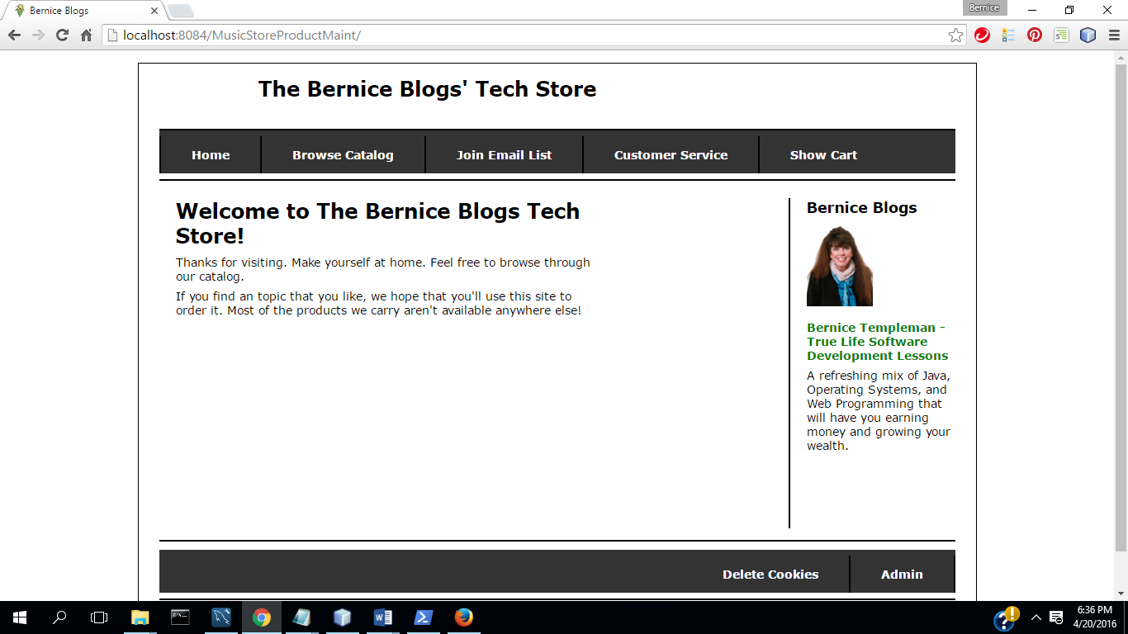

(2) Select Admin

**Admin Login:**

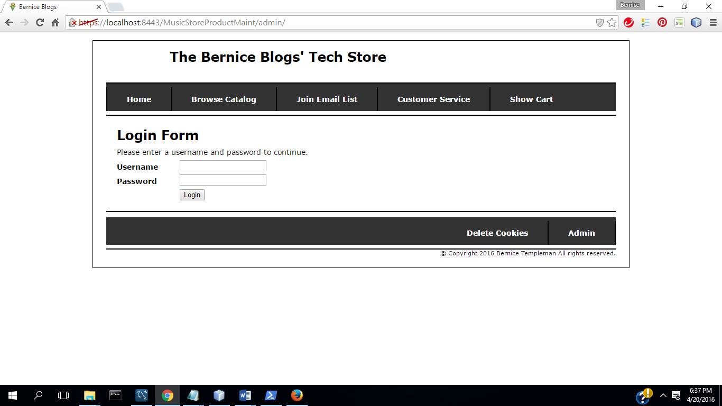

(3) Login: **Admin Menu**

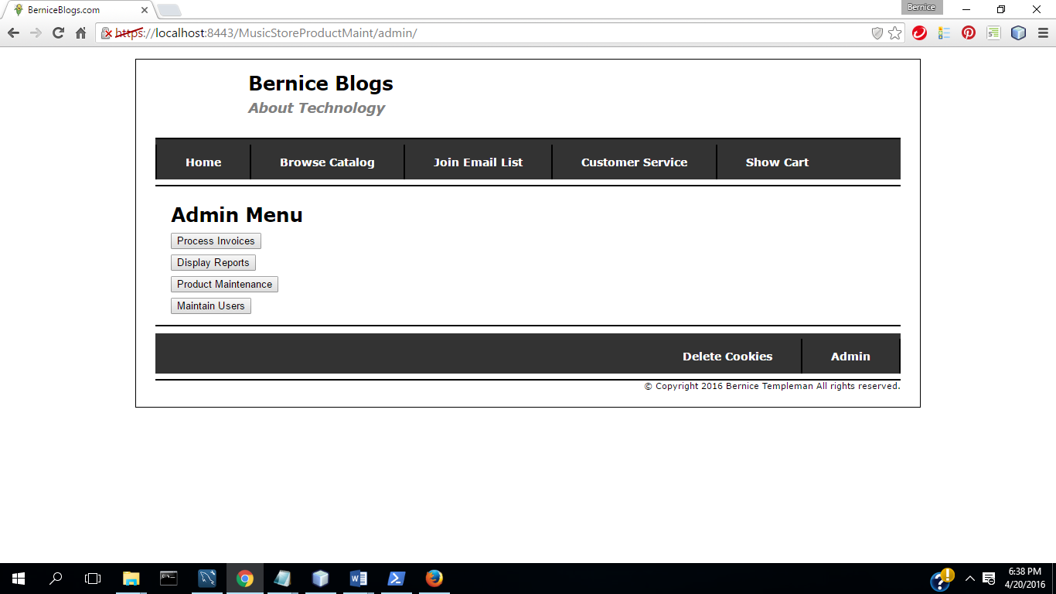

(4) Select Product Maintenance

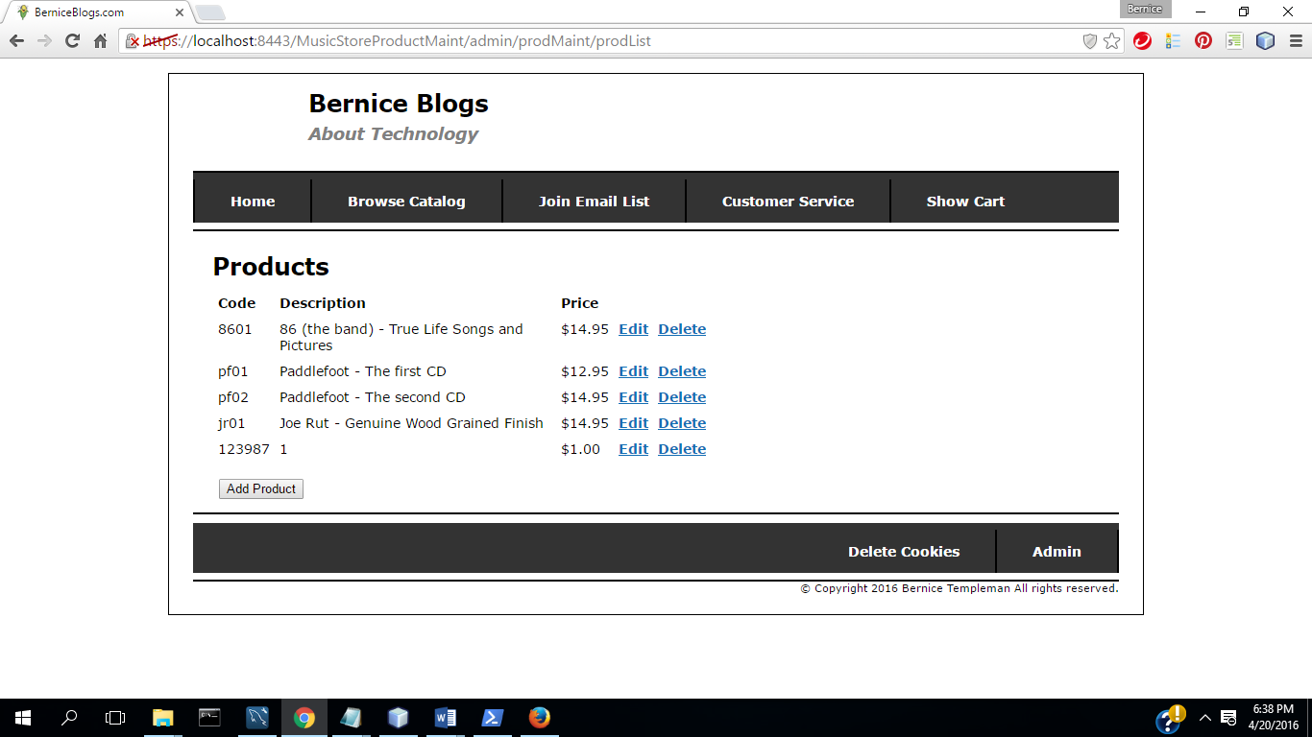

(5) Select Add Product

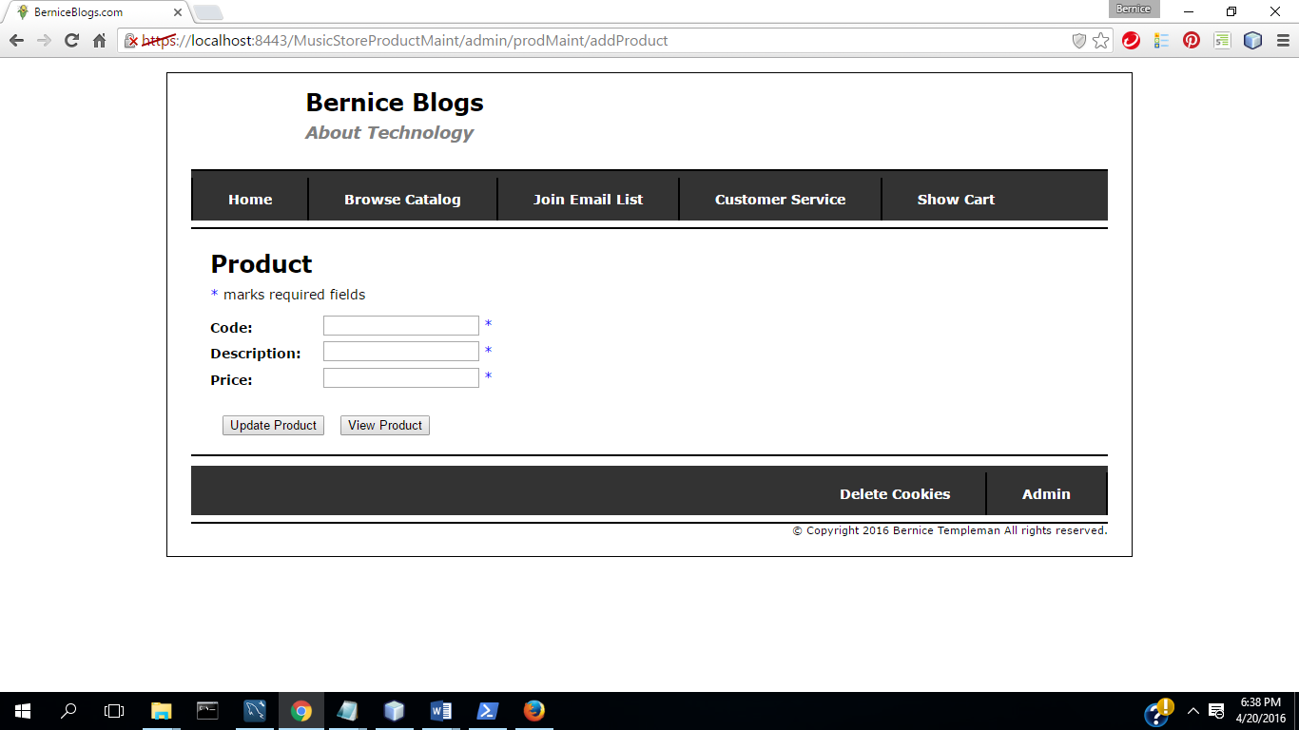

(6) Select Update

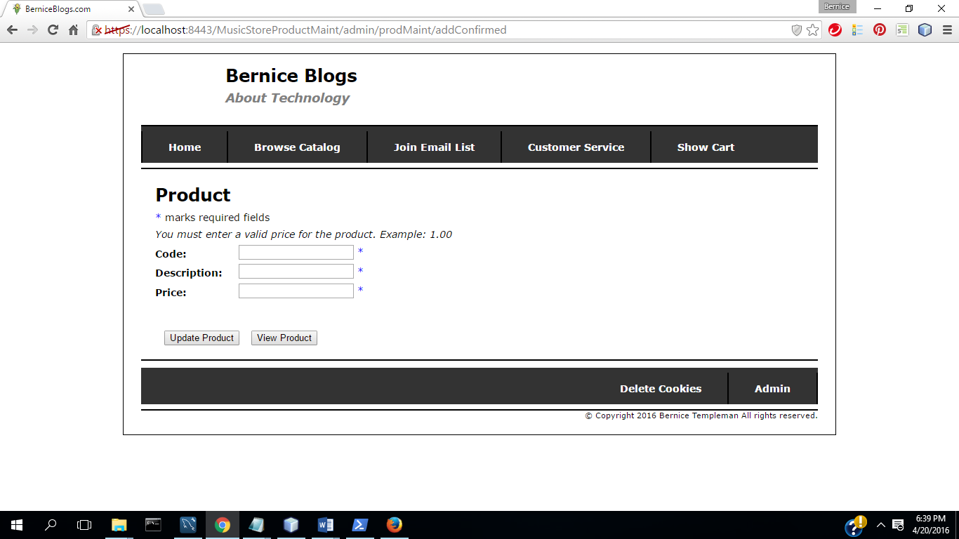

(7) Complete fields with valid data

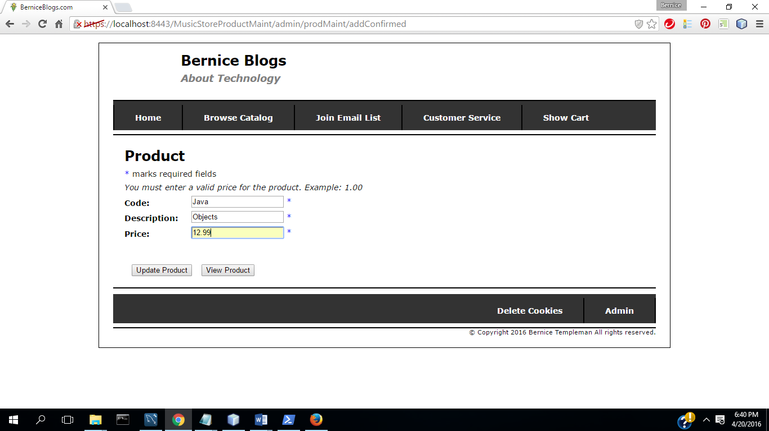

(8) Select Update( Commit Transaction & Update Inventory)

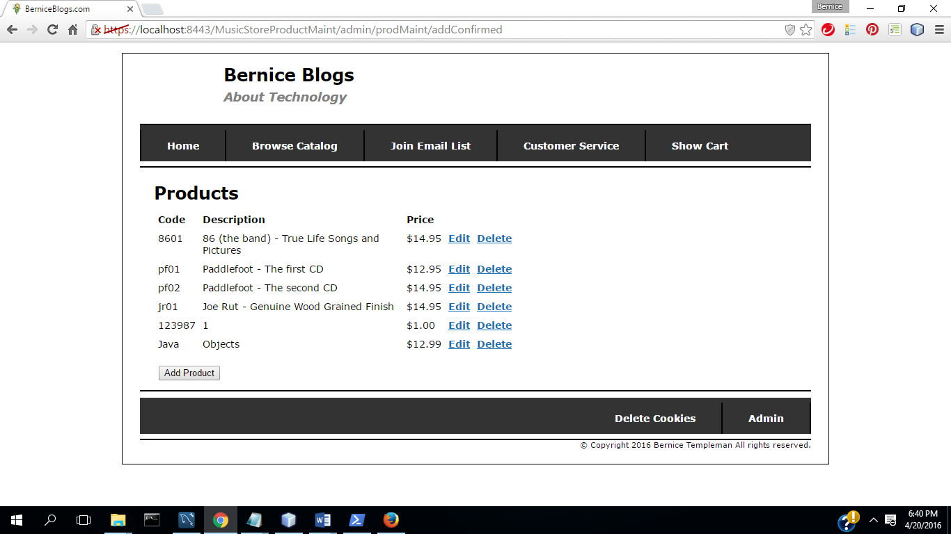

(9) Select Delete Product

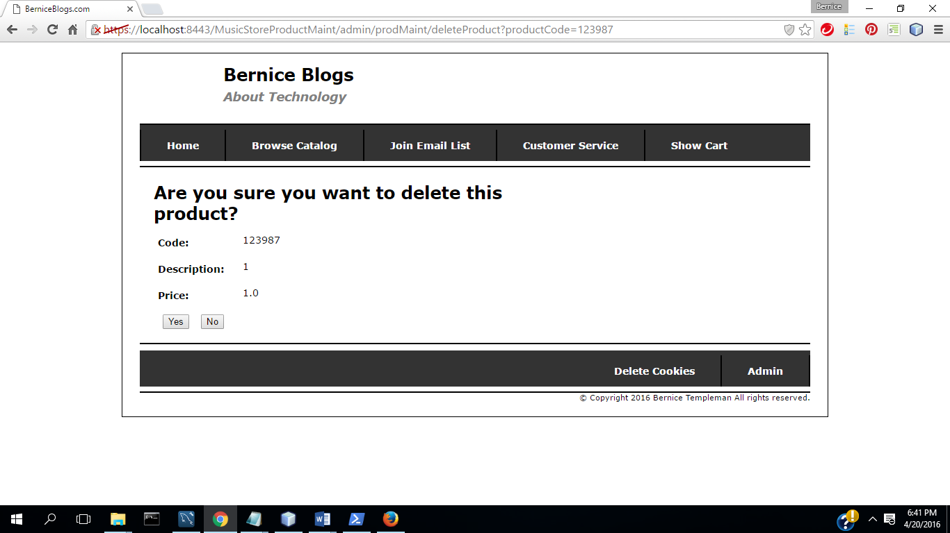

(10) Select No

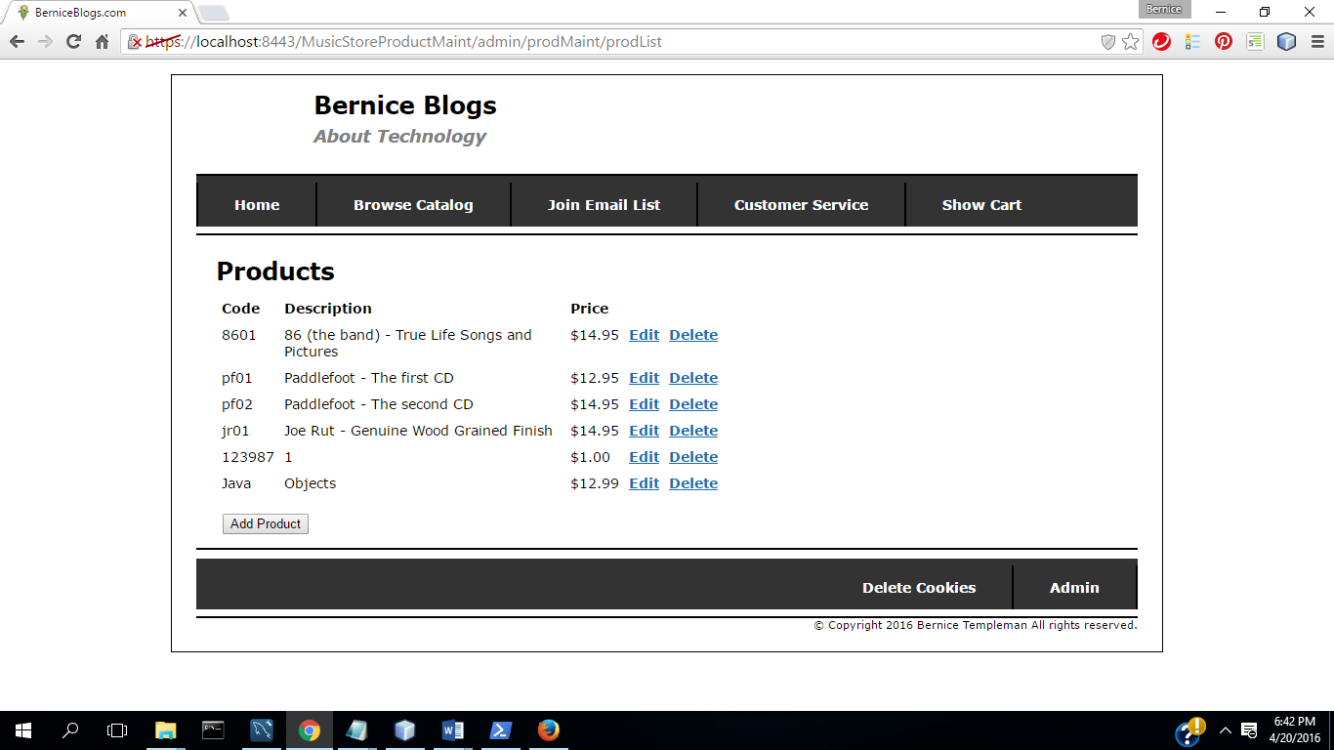

(11) Select Delete Product

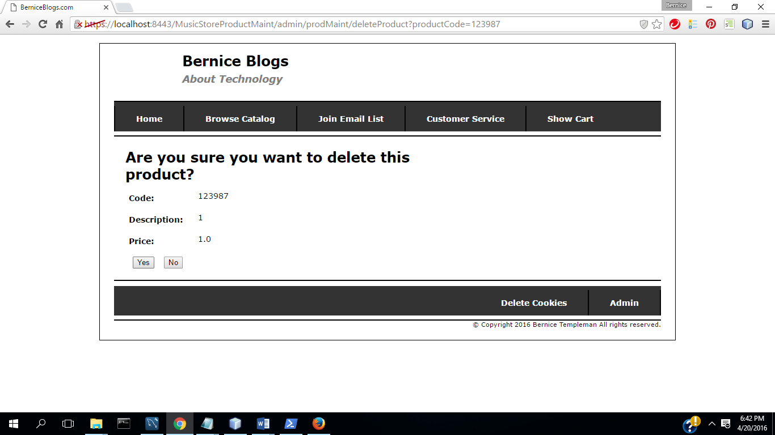

(12) Select Yes (Commit Transaction &Update Inventory)

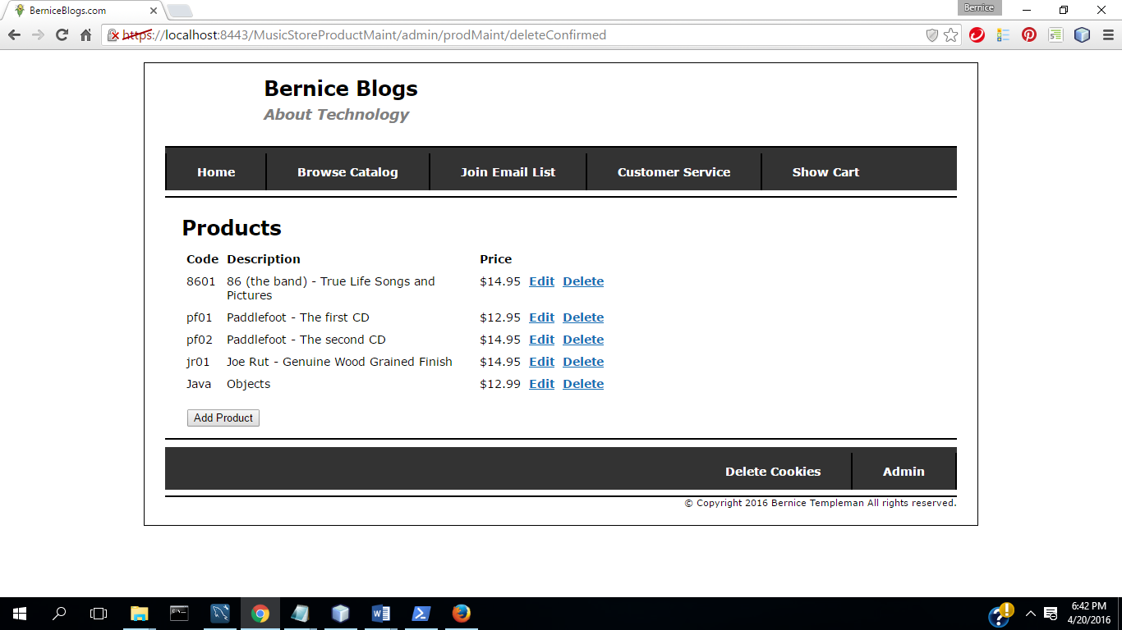

(13)Select Admin

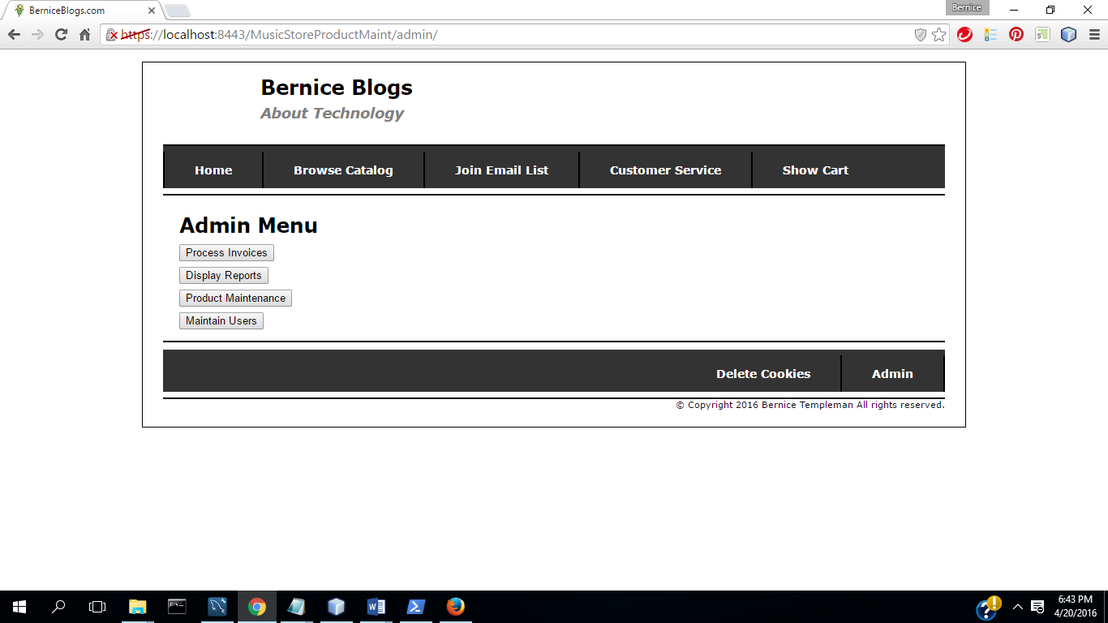

(14)Select Process Invoices

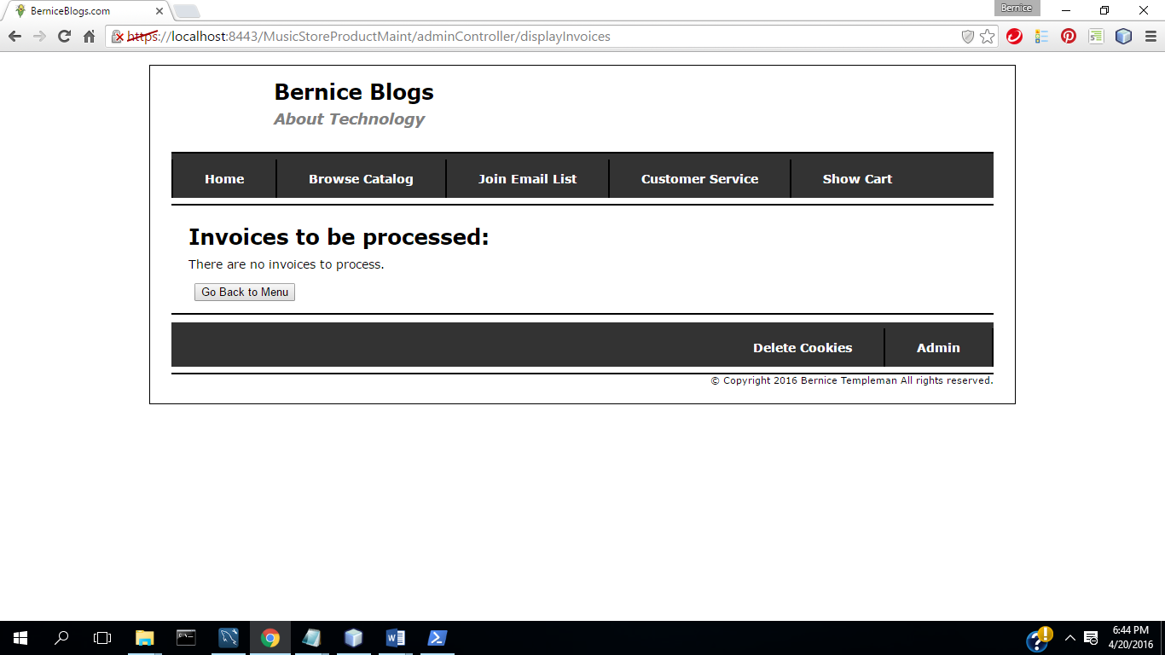

15 ) Select Go Back to Menu

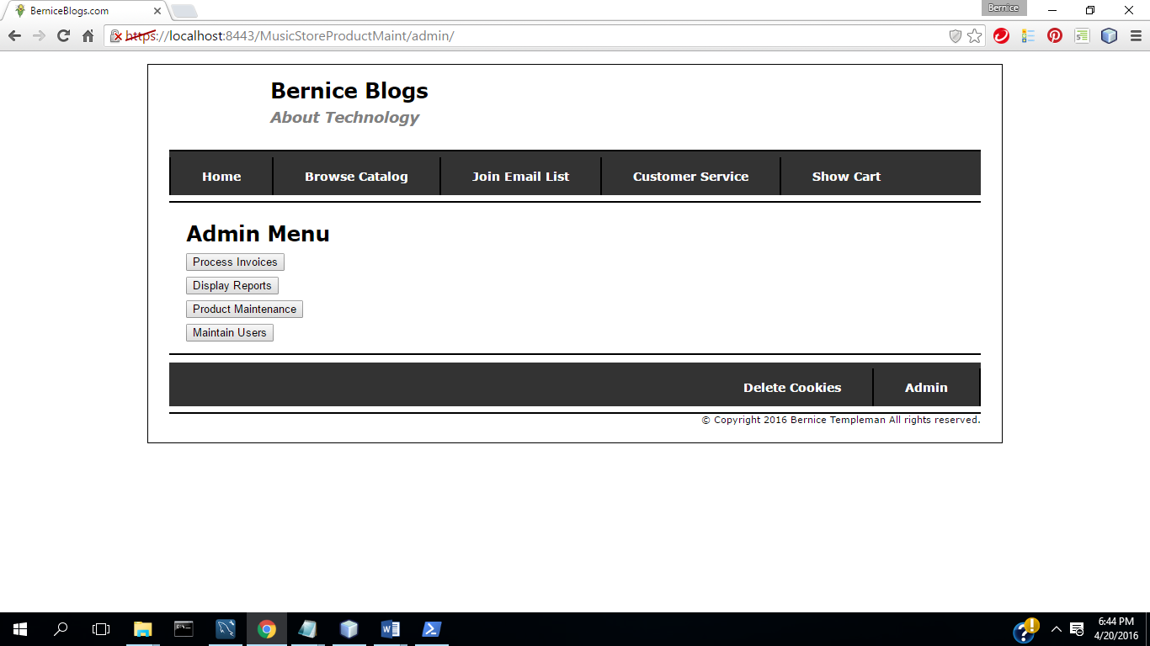

16) Select Display Reports

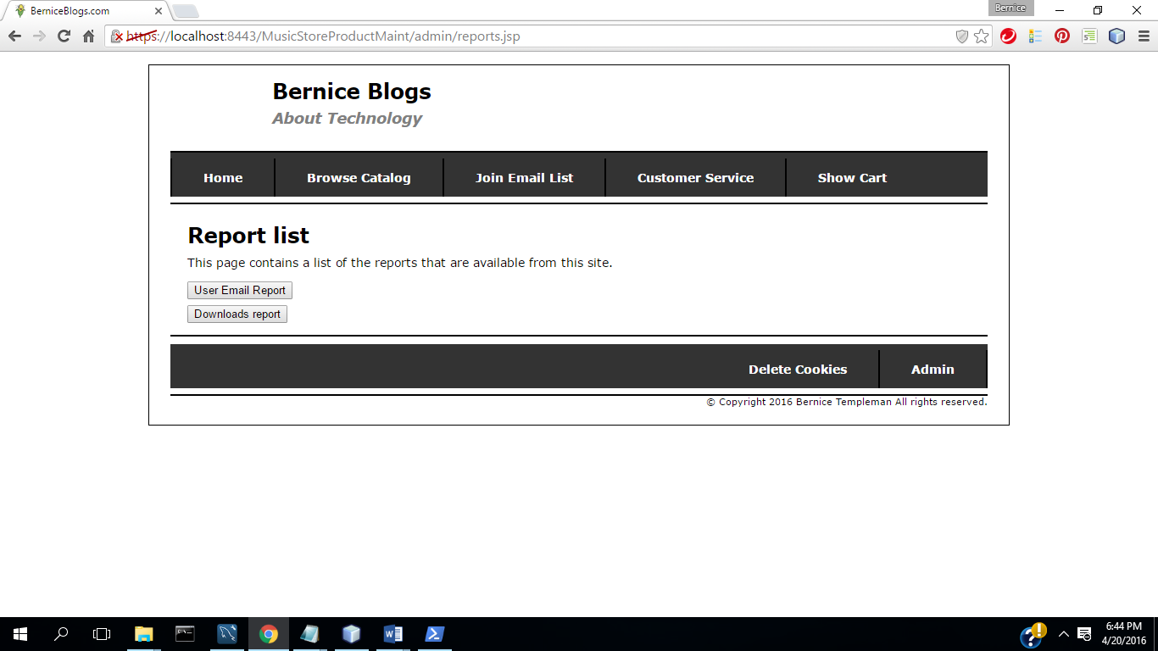

17)Select User Email Report

18) Save (Download )& open in excel

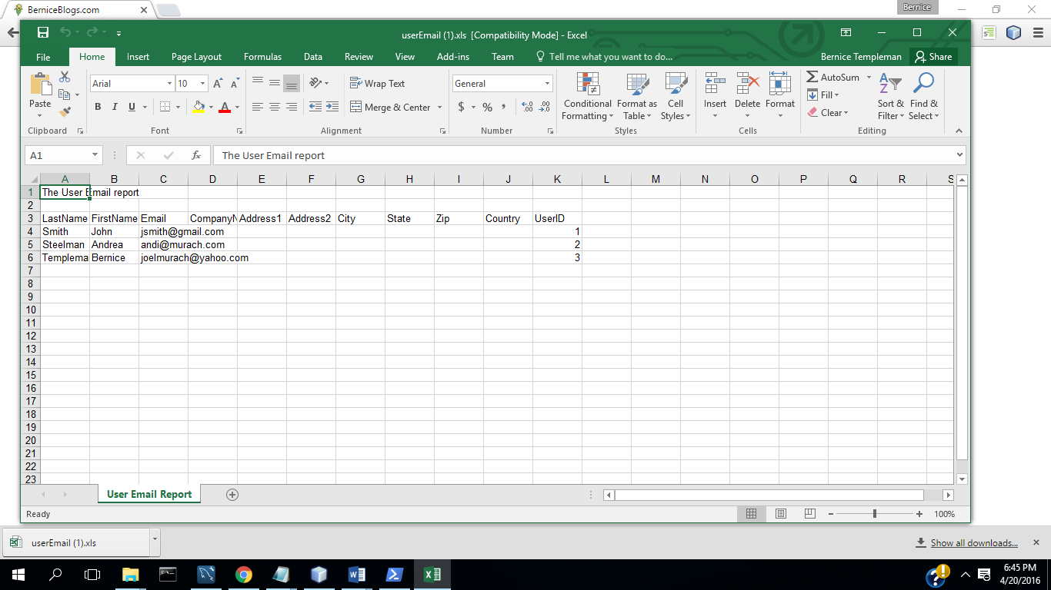

19)Select Downloads report

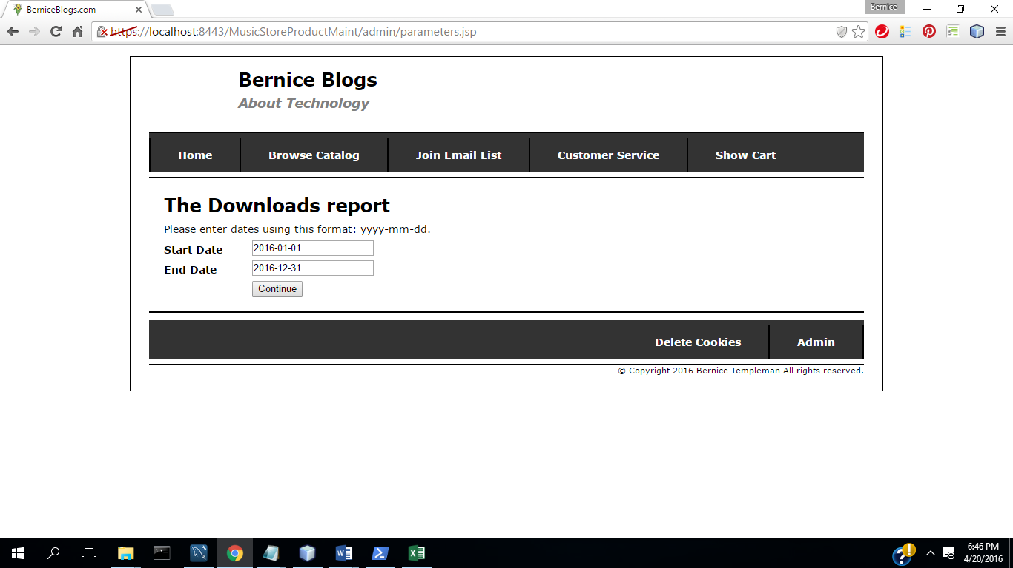

20) Continue

21) Save and open in excel

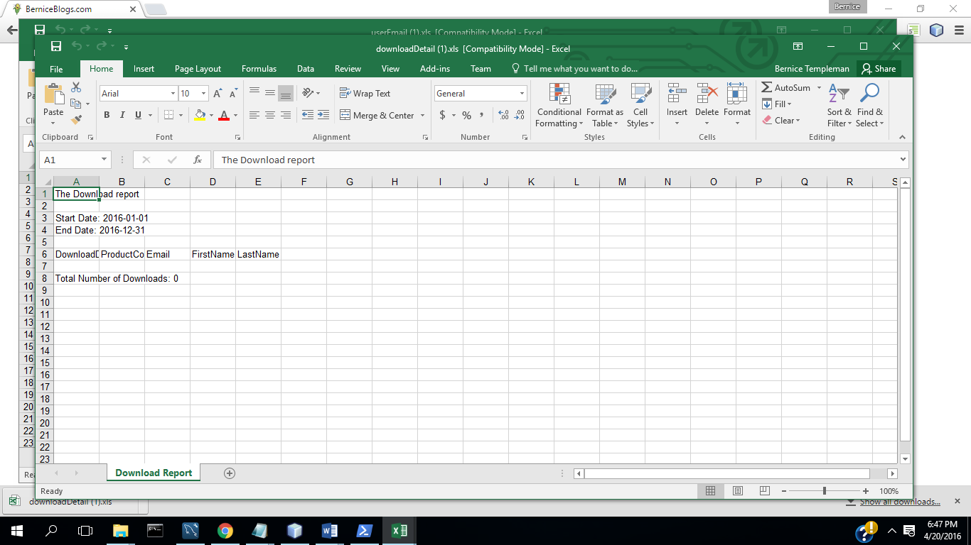

22.) Select Admin

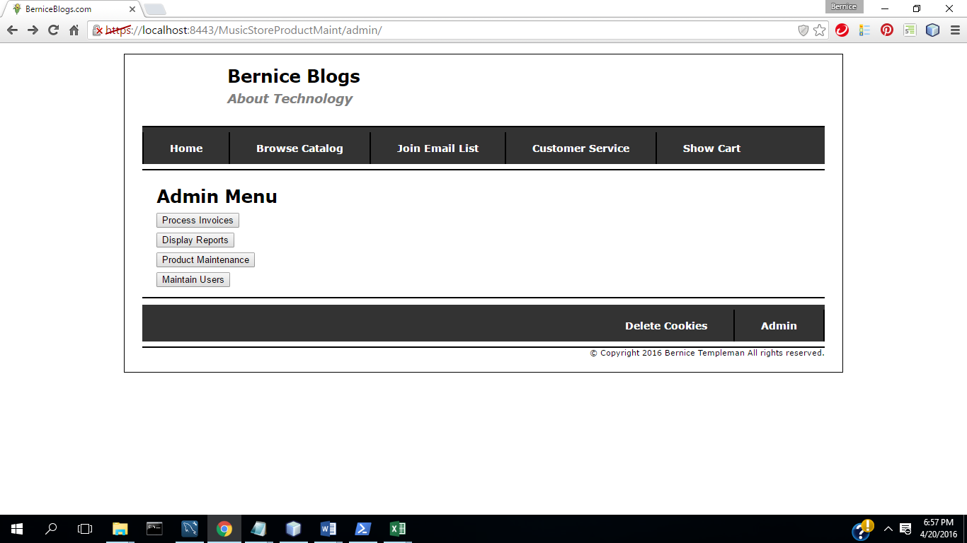

23) Select Maintain Users

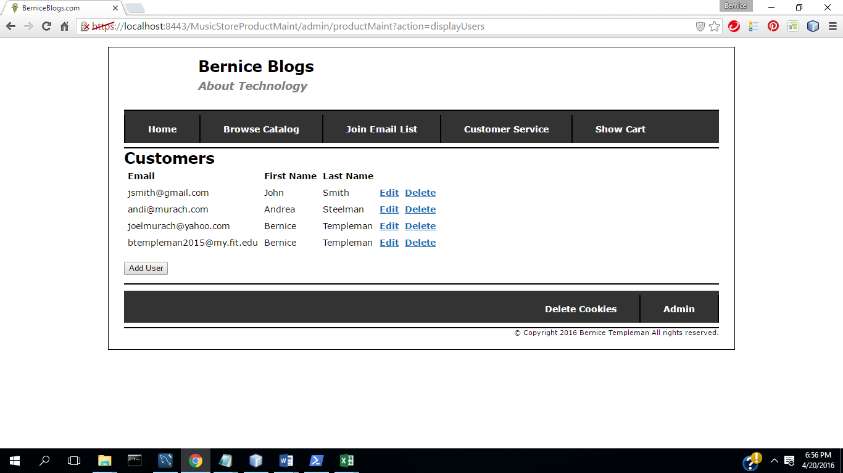

24.) Select Add User

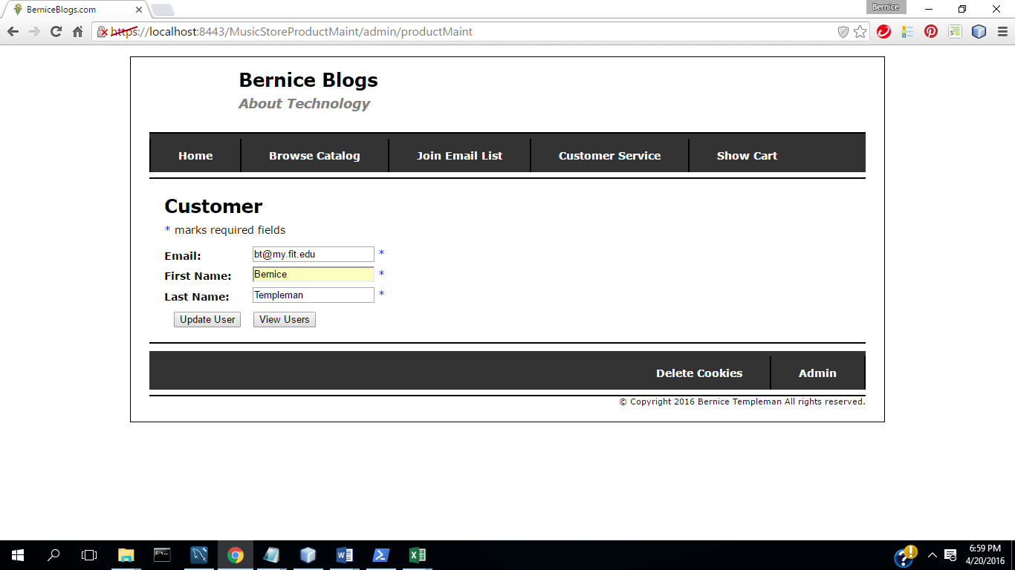

**25.) Select Update**

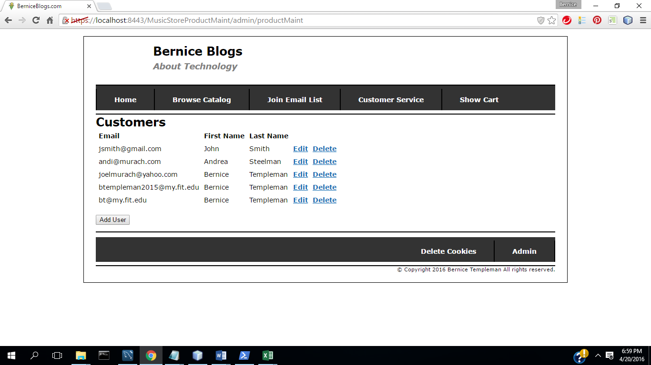

**26.) Select Edit**

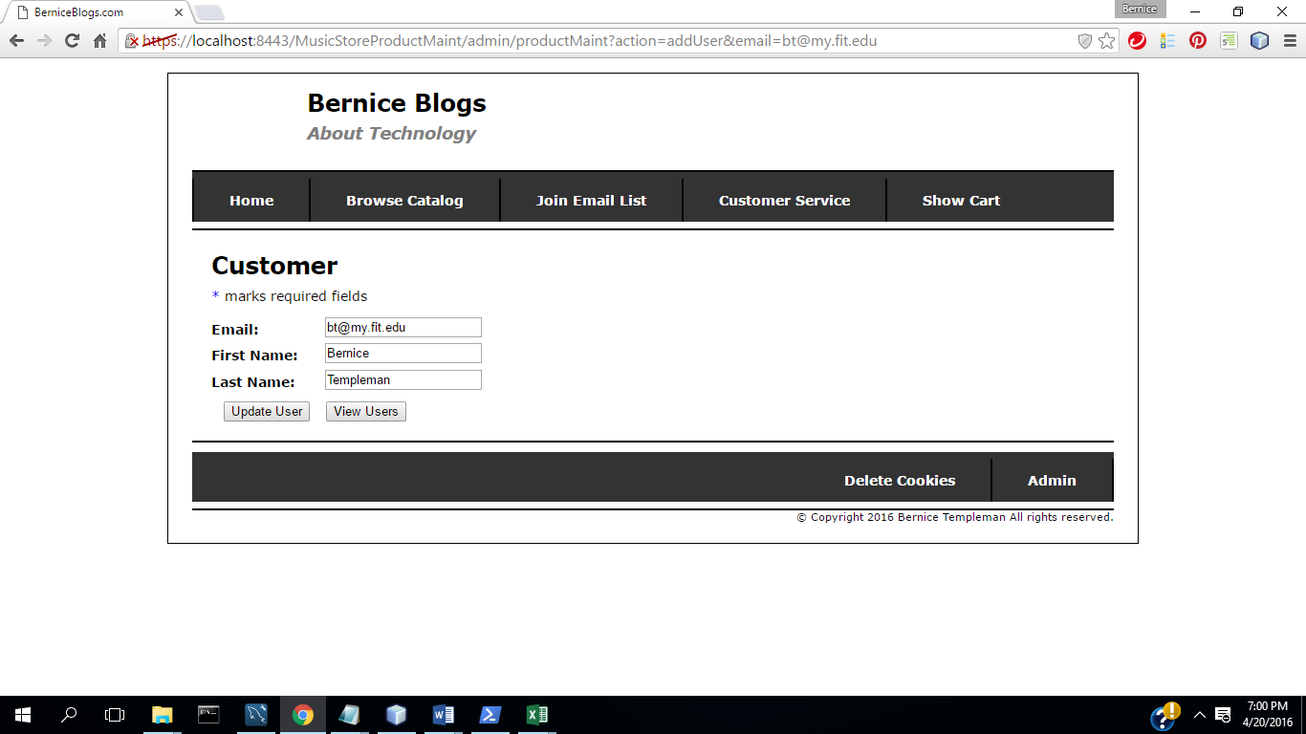

**27.) Change Data**

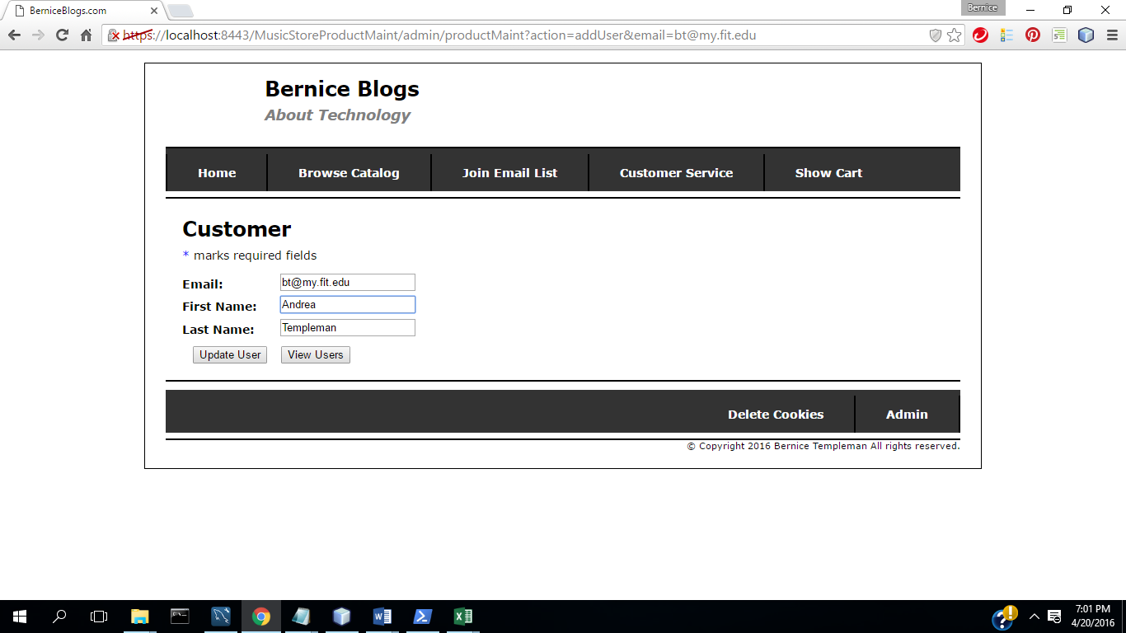

**28) Select Update**

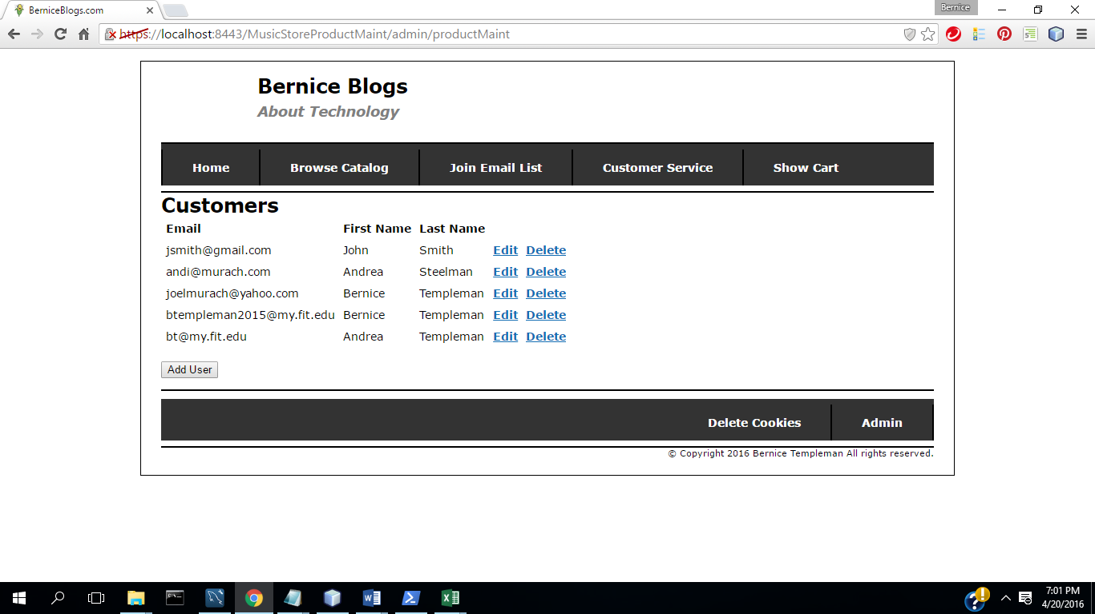

**29) Select Delete**

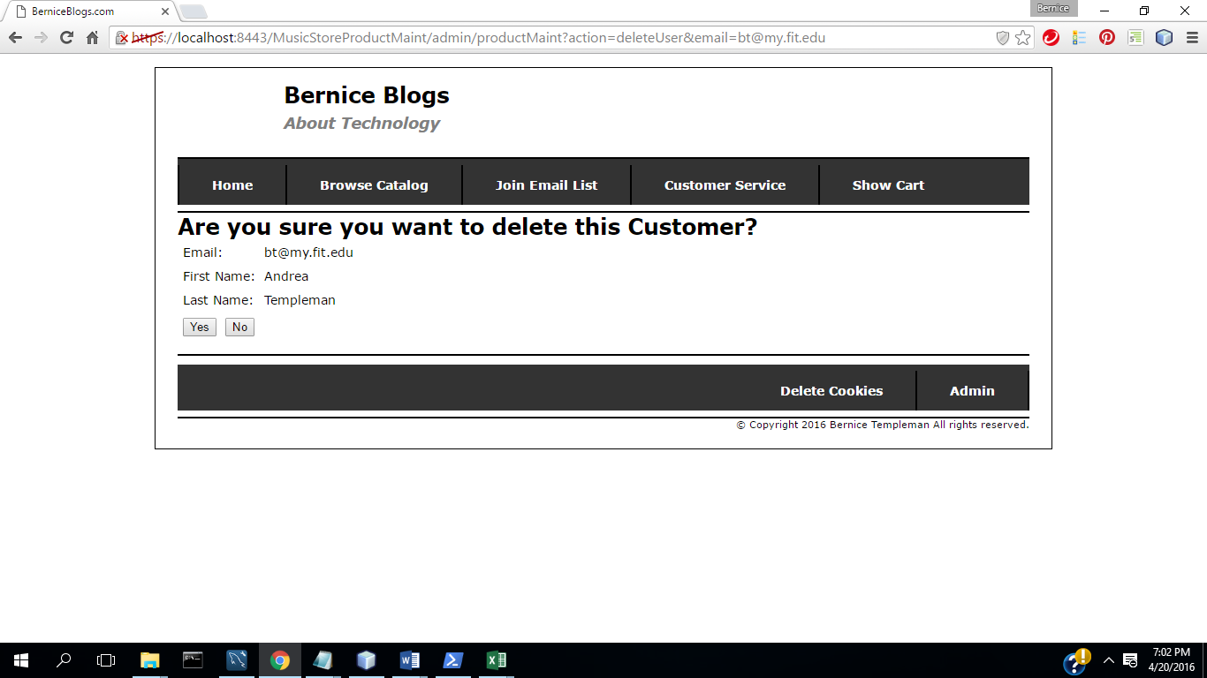

**30) Select yes**

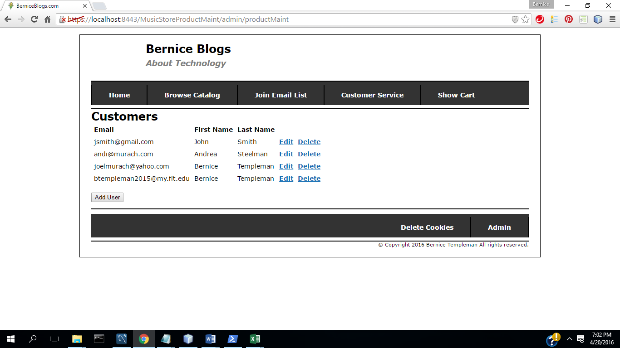

**TC2: Music Store App**

(1) select Home

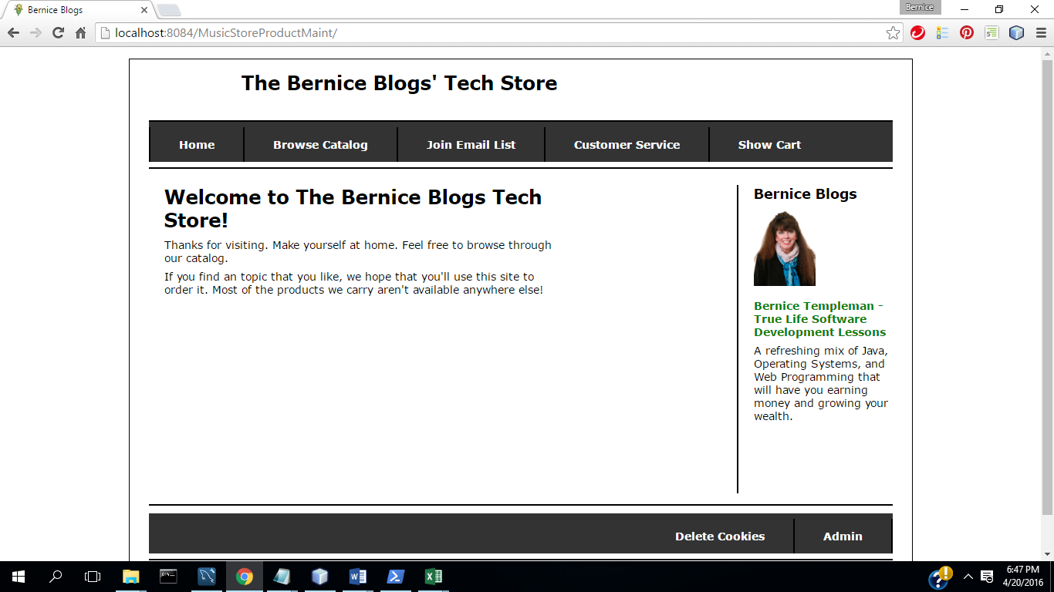

(2) Select Browse Catalog

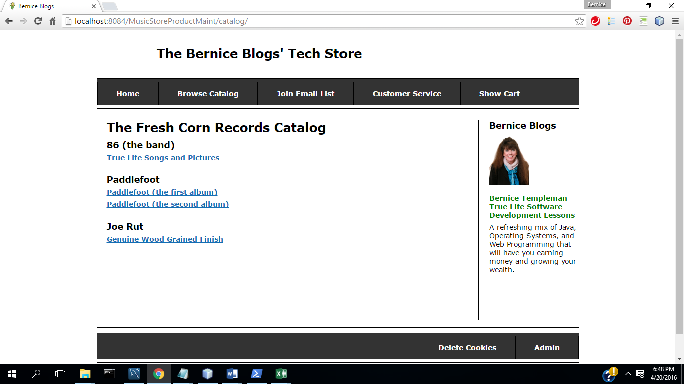

3,) Select Product

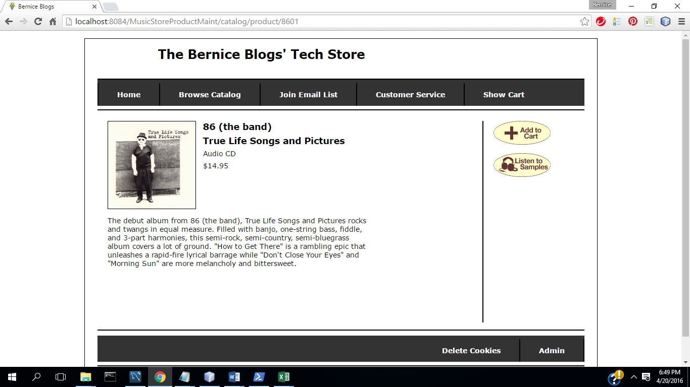

4.) Select Listen

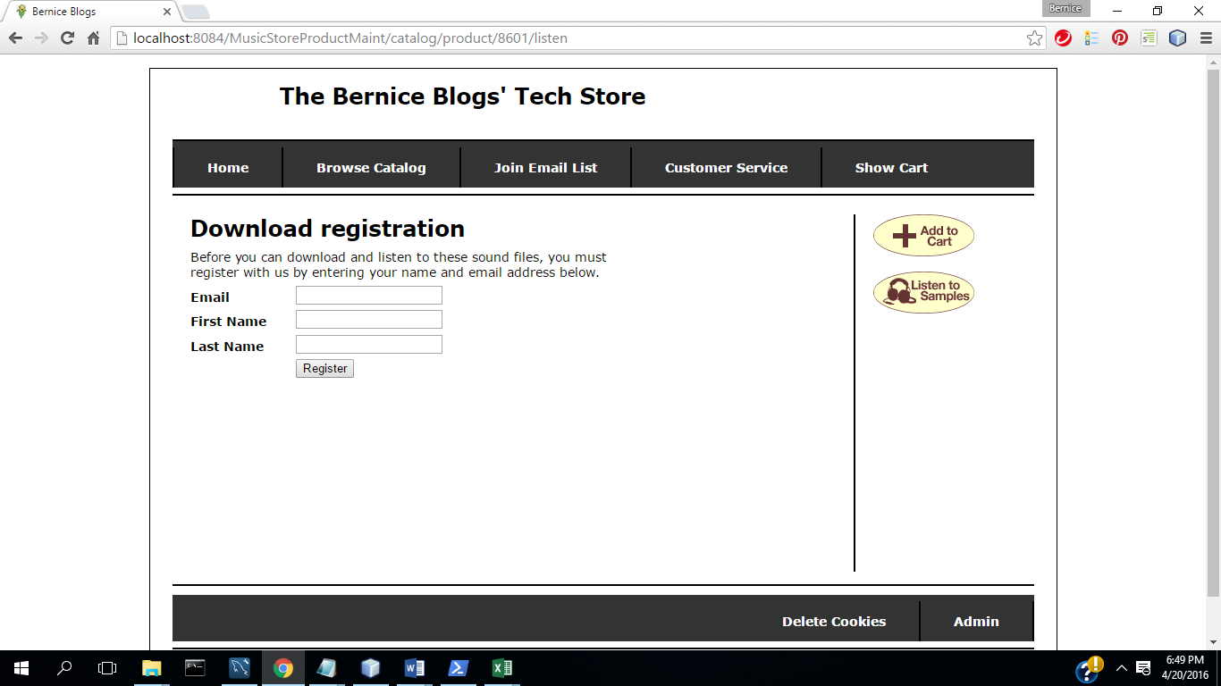

5.) Enter Information

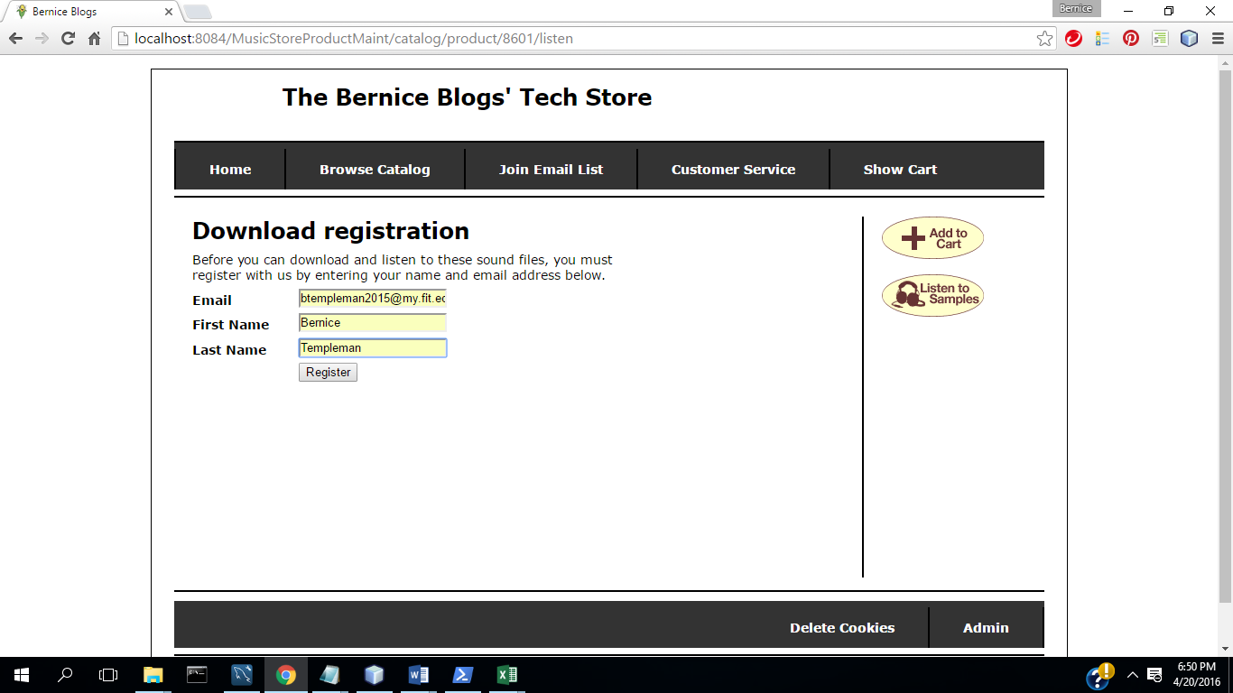

6) Select register

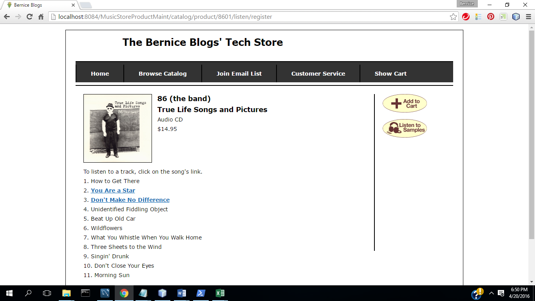

7) Select Song

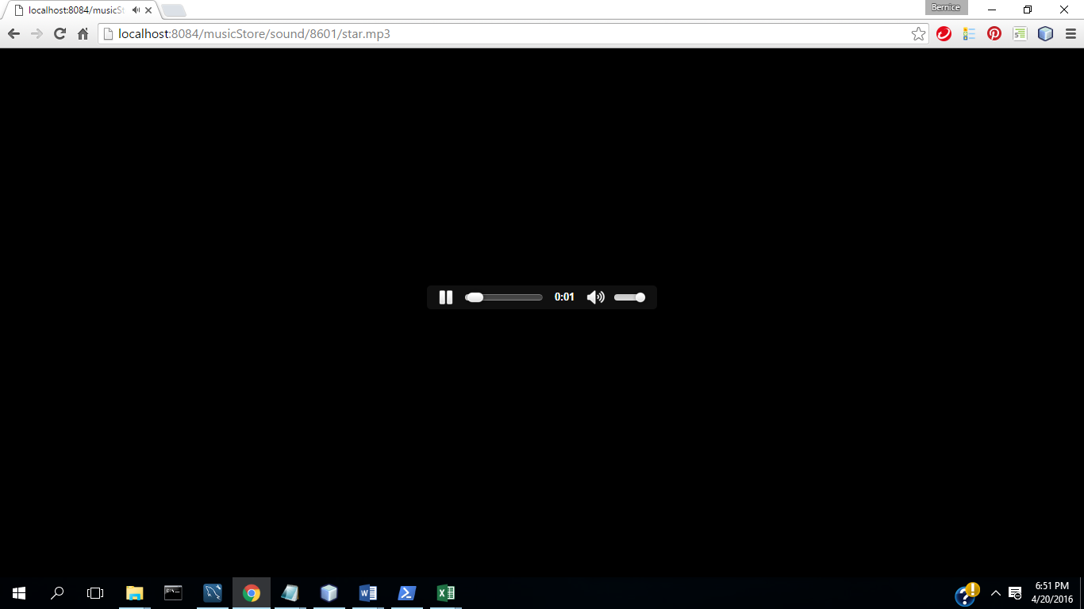

8.) Select Back in Browser until get back to page

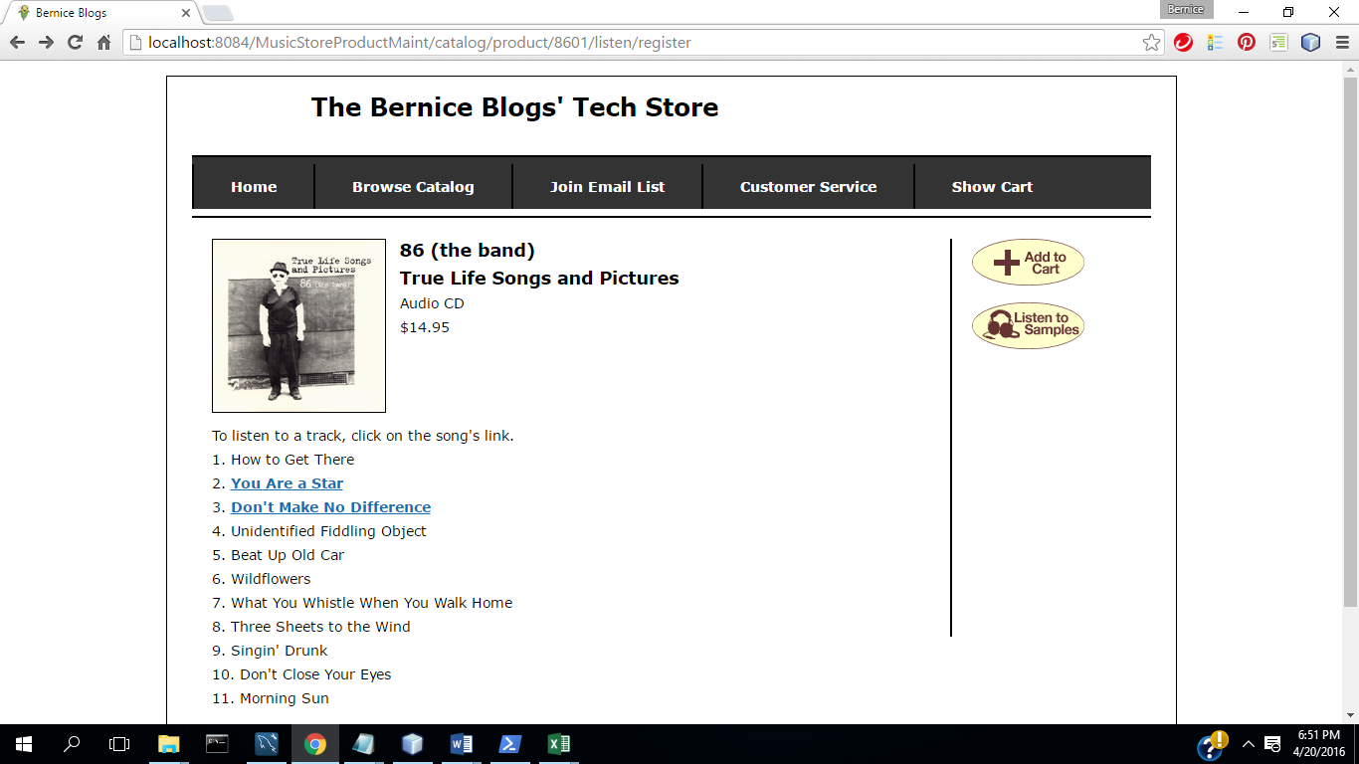

9.) Select Add to Cart

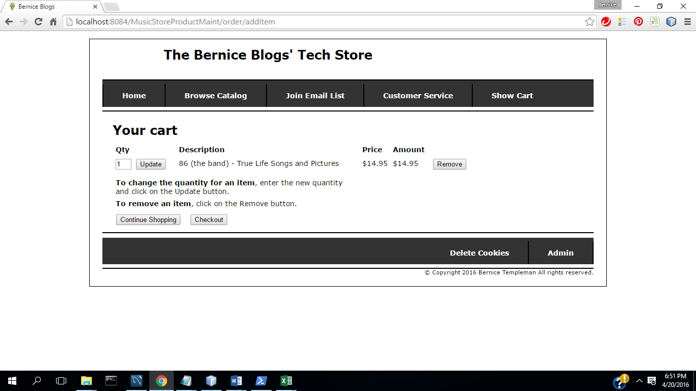

10.) Select Checkout

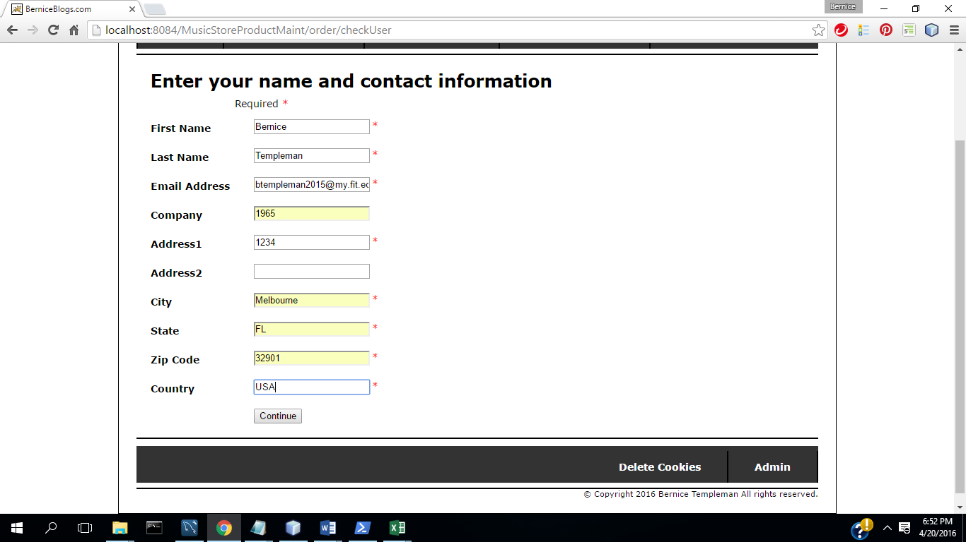

11.)Select Continue

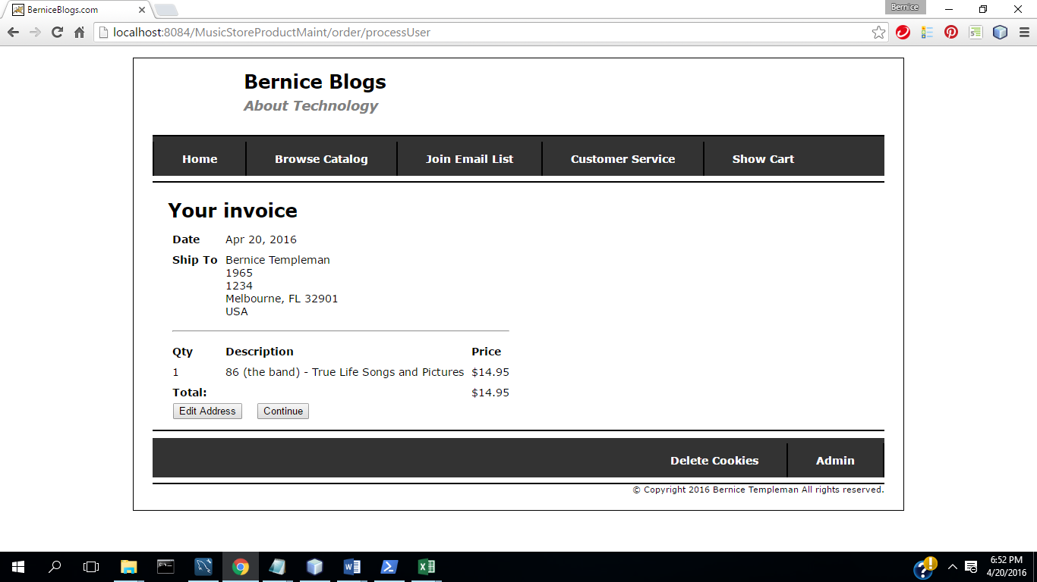

12.) Select Continue

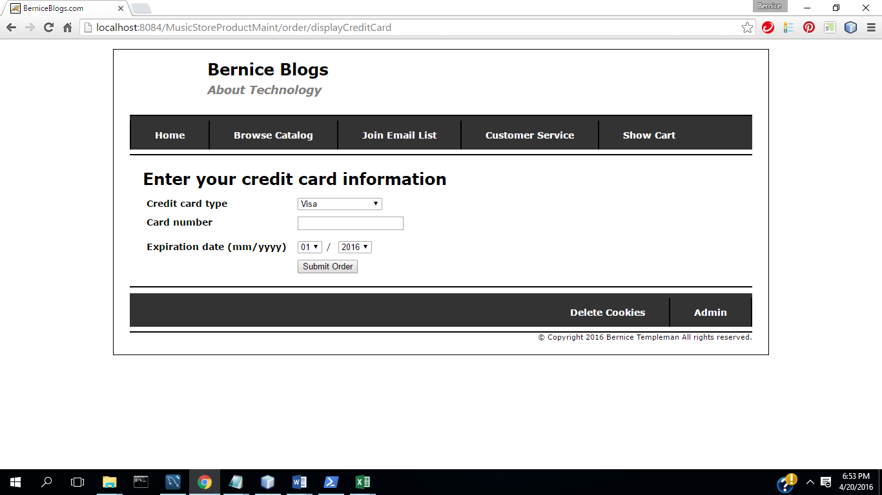

13) Complete fields

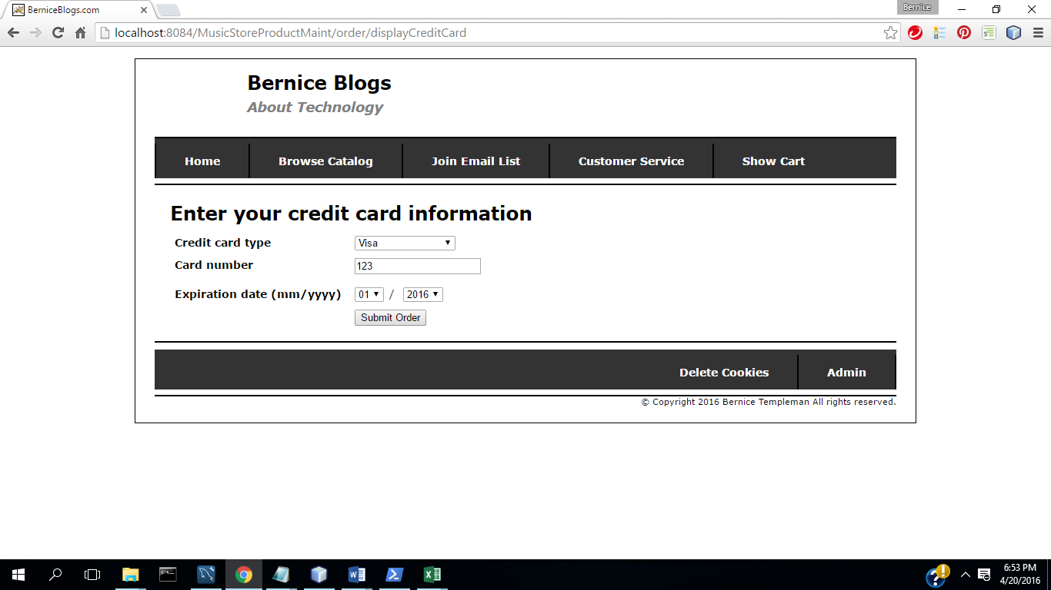

14.) Select Submit Order

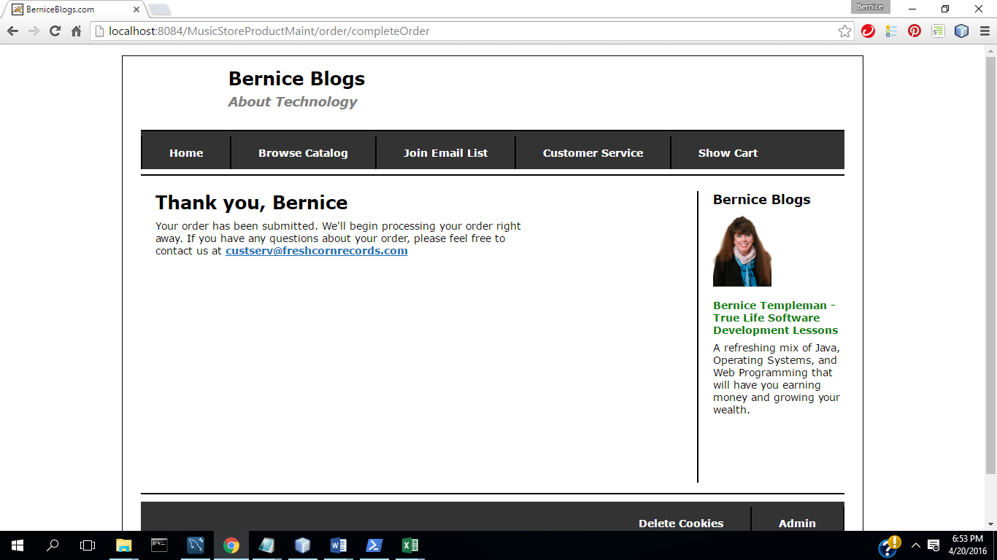

15) Select Join Email list

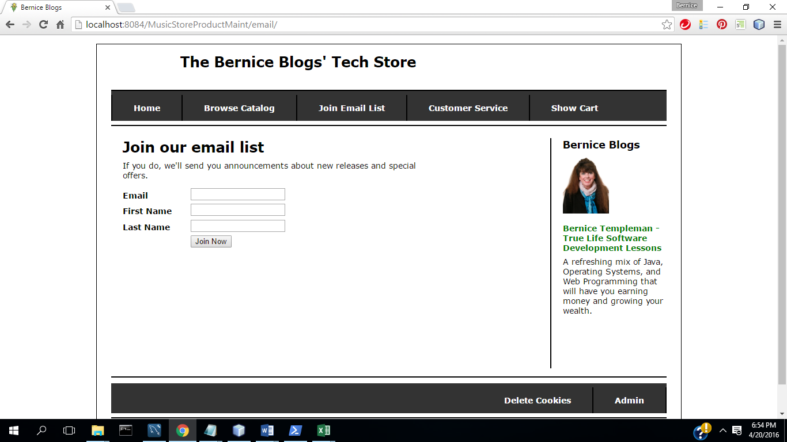

17.) Enter information

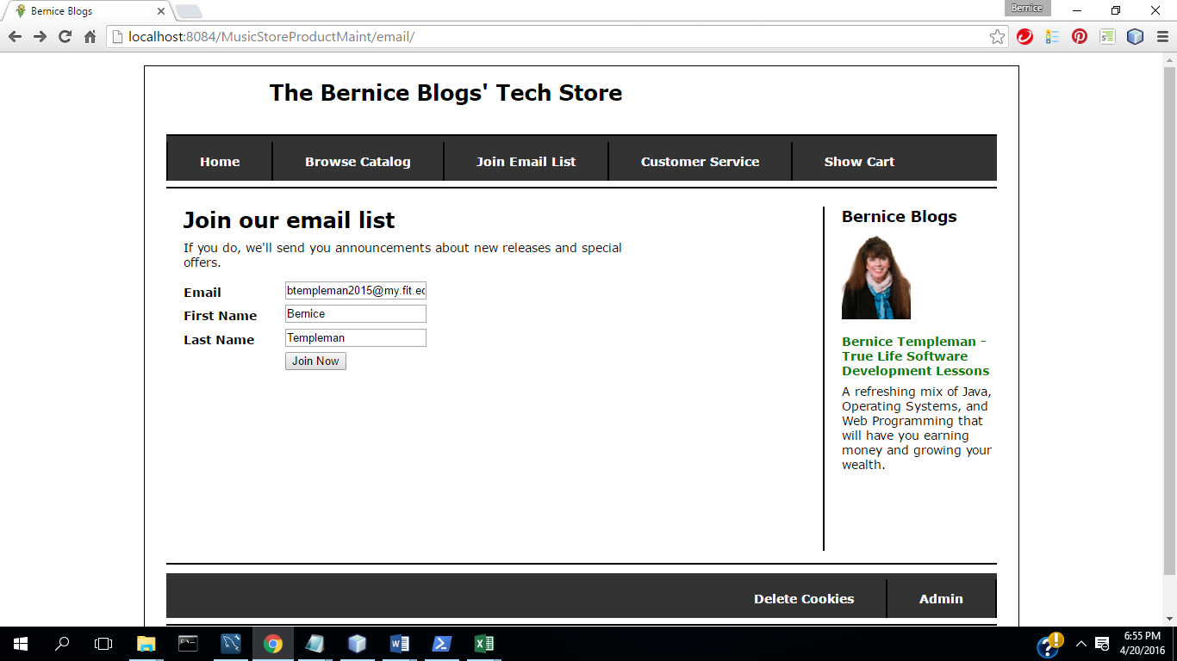

Join Now

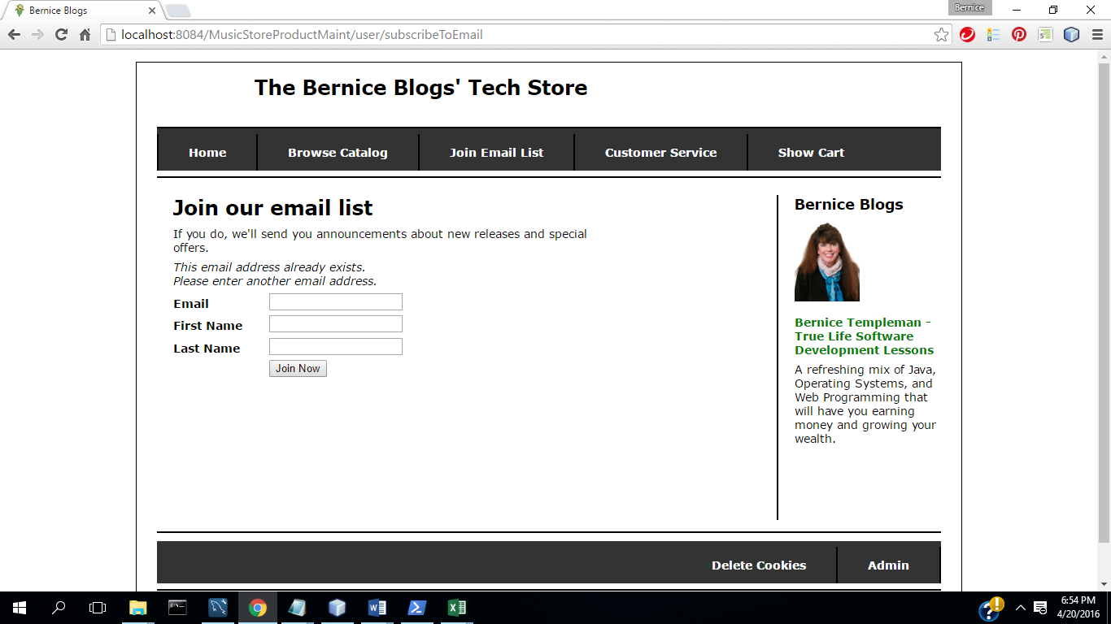

16) Select Customer Service

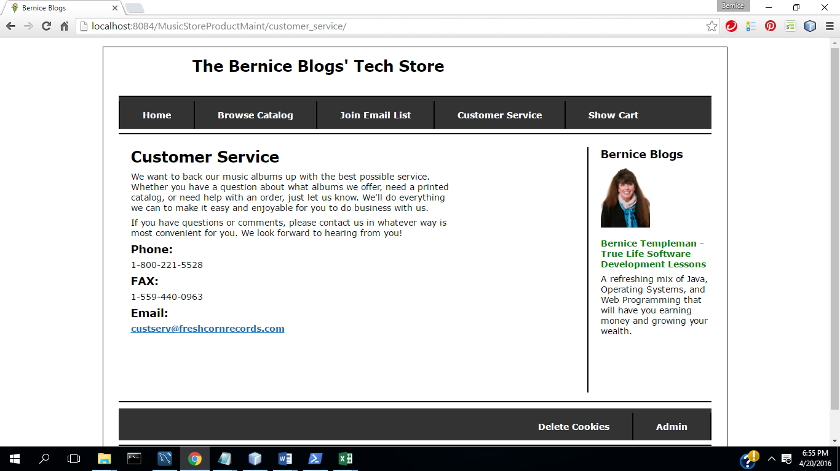

**17) Select delete Cookies**

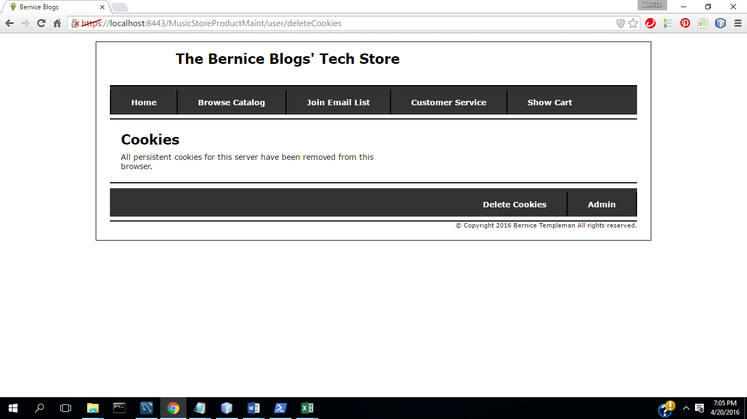

**(b) All program code for each part.**

In zipped file of NetBean project directory.

**(d) Test procedure/plan and implementation. What did you do to the test the program.**

**TC1: Admin**

**(1)Start App (Home Page):**

(2) Select Admin

(3) Login: **Admin Menu**

(4) Select **Product Maintenance**

(5) Select Add Product

(6) Select Update

(7) Complete fields with valid data

(8) Select Update( Commit Transaction & Update Inventory)

(9) Select Delete Product

(10) Select No

(11) Select Delete Product

(12) Select Yes (Commit Transaction &Update Inventory)

(13) Select Admin

(14) Select Process Invoices

(15 ) Select Go Back to Menu

(16) Select Display Reports

(17) Select User Email Report

(18) Download & open in excel

(19) Select Downloads report

(20) Continue

(21) Save and open in excel

22.) Select Admin

23) Select Maintain Users

24.) Select Add User

25.) Select Update

26.) Select Edit

27.) Change Data

28.) Select Update

29) Select Delete

30) Select yes

**TC2: Music Store App**

(1) select Home

(2) Select Browse Catalog

(3) Select Product

(4) Select Listen

(5) Enter Information

(6) Select register

(7) Select Song

(8) Select Back in Browser until get back to page

(9) Select Add to Cart

(10) Select Checkout

(11) Select Continue

(12) Select Continue

(13) Complete fields

(14) Select Submit Order

(15) Select Join Email list

(16) Select Customer Service

(17) Select Delete Cookies

Purchase a Music Album  (provide screen print for items included in your test cases)

(1) Login

(2) Account authenticated

(3) Select/Purchase product

(4) Commit Transaction

(5) Update Inventory

# Use Case Diagrams





# Use Cases

## ManageStore: Browse

## ManageStore: UpdateCart

## ManageStore: PlaceOrder

## ManageAccount: Register

## ManageAccount: Login

## ManageAccount: Update

# Specific Requirements

This subsection contains the requirements for the e-store. These requirements are organized by the features discussed in the use case diagrams.

## Manage Store: Browse

#### S1: Shall display all the products that can be purchased.

#### S2: Shall provide browsing options to see product details.

#### S3: Shall allow user to select the product to purchase.

## Manage Store: Update Cart

#### S1: Shall allow products to be added to the cart.

#### S2: Shall allow products to be deleted from the cart.

#### S3: Shall allow the quantity of the products to be updated.

## Manage Store: Place Order.

S1: Shall require the user to enter their information.

S2: Shall require the customer to confirm the invoice.

S3: Shall require the user to enter credit card information after the order is confirmed.

S4: Shall display an order confirmation page.

## Manage Account: Register

S1: Shall allow user to create profile.

S2: Shall require a username (email address) and password.

S3: Shall allow user to register for newsletters and surveys in the profile.

S4: Shall require the user to enter their First name and Last name.

S5: Shall allow the user to enter their address in the profile.

## Manage Account: Login

S1: Shall require the user to enter their email address.

S2: Shall require the user to enter their password.

S3: Shall allow the user to update their profile.

S4: Shall allow the user to view their profile.

S5: Shall authenticate the users email and password.

## Manage Account : Update

S1: Shall allow user to update the profile information.

S2: Shall allow the user to change their password.

S3: Shall the user to change their address.

S4: Shall allow the user to options to receive email.

S5: Shall allow the user to change their name.

Design Document for Web Programming Project.

This is a prototype for a web application to be integrated into an existing website.

1. Store Home Screen

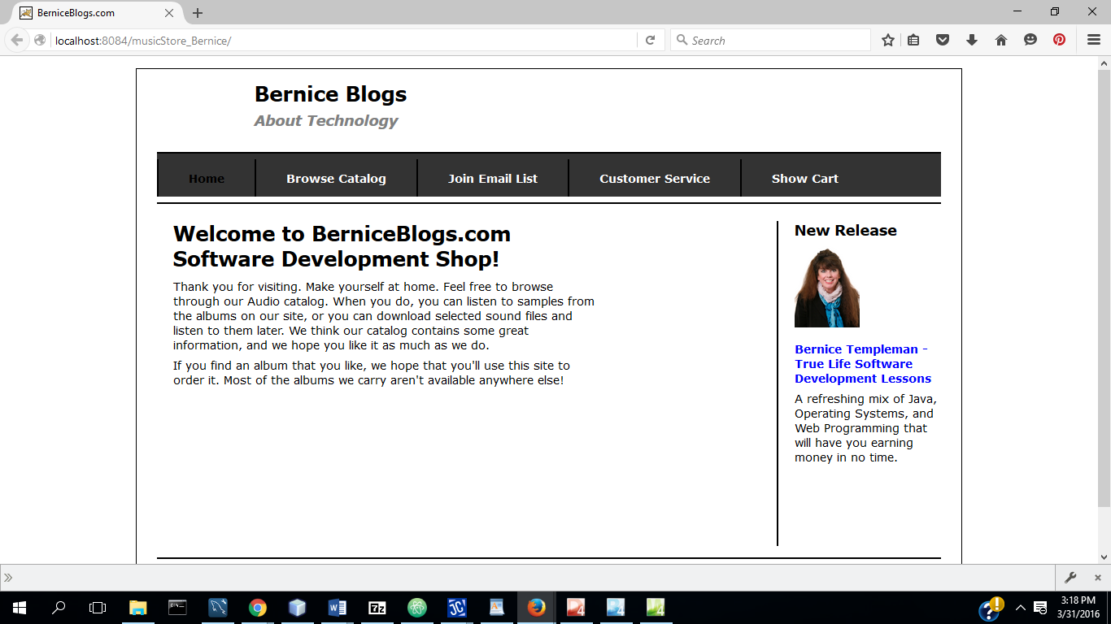

1. Browse Catalog

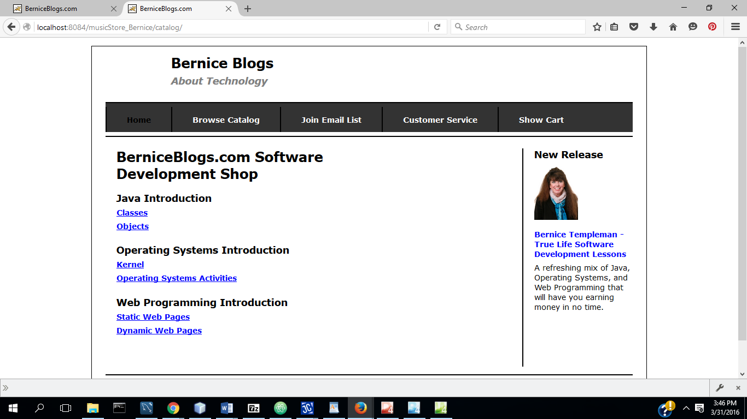

1. Join Email List

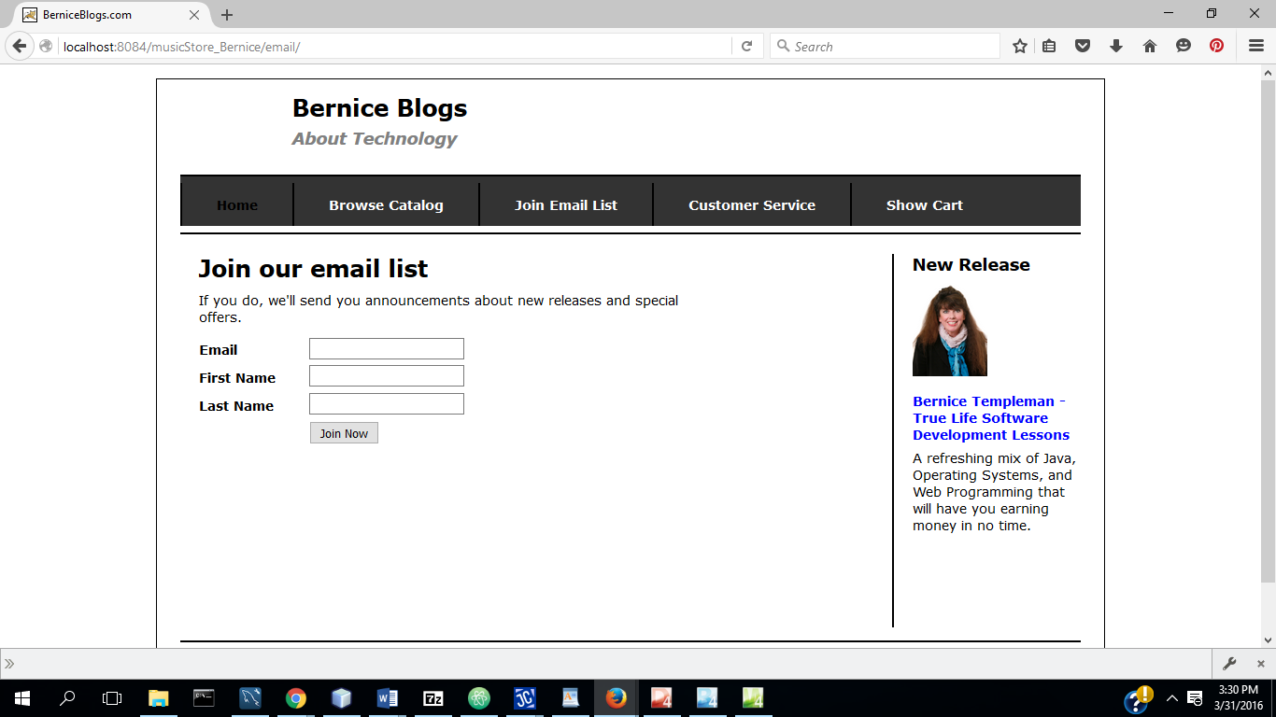

1. Customer Service

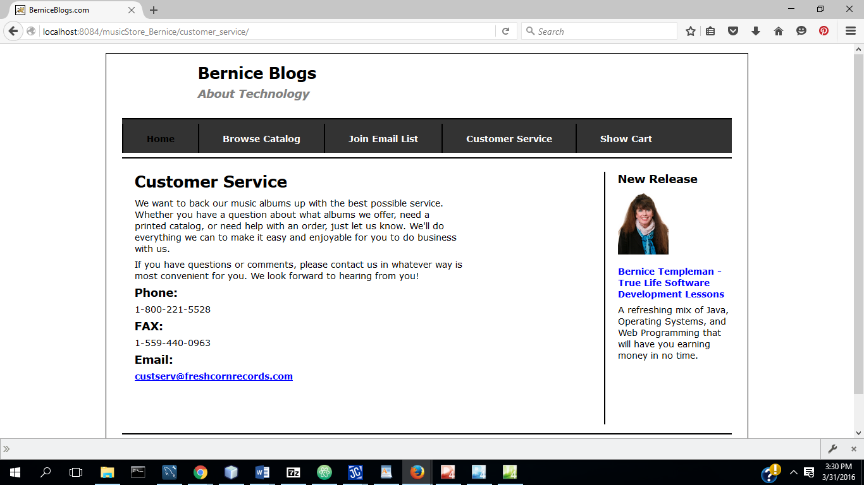

1. Show Cart

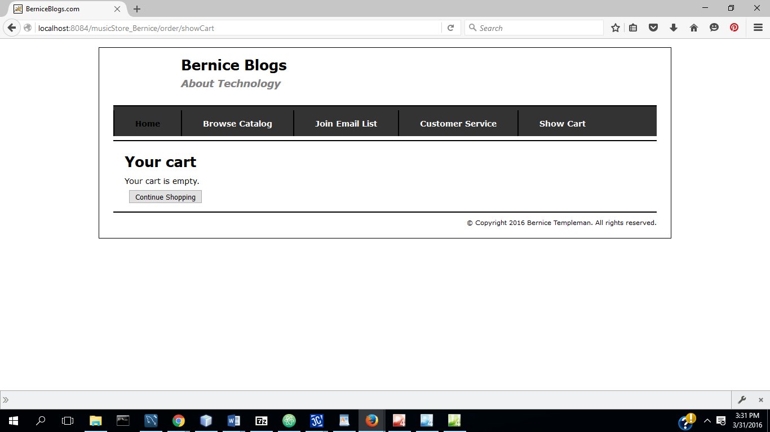

1. Product Information Page (using Music store product for prototype)

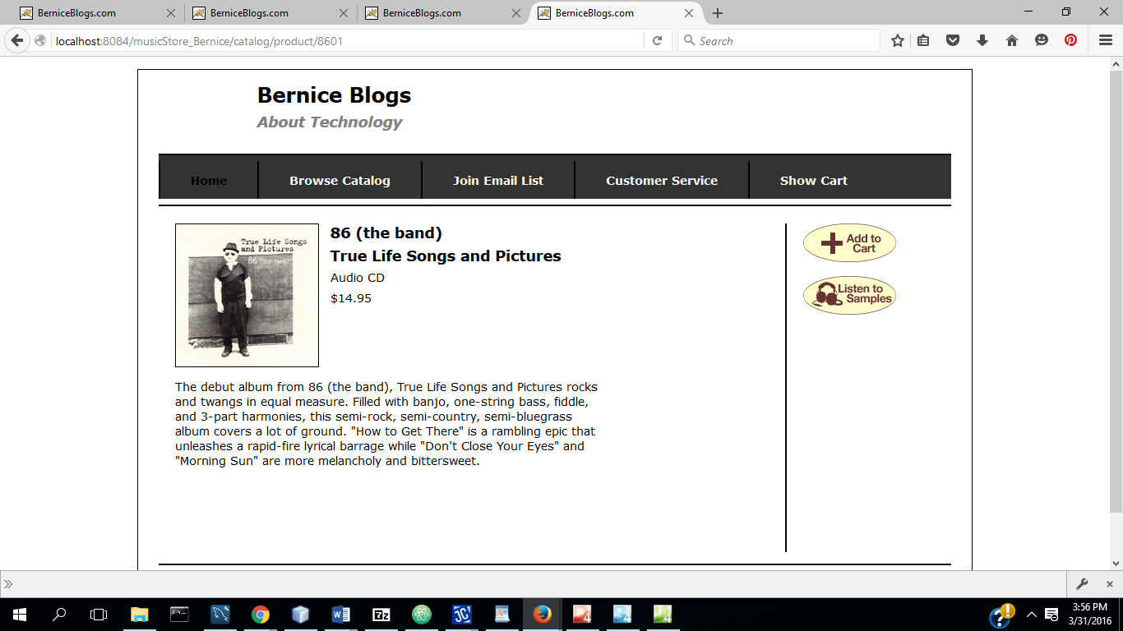

1. Product Added to Cart:

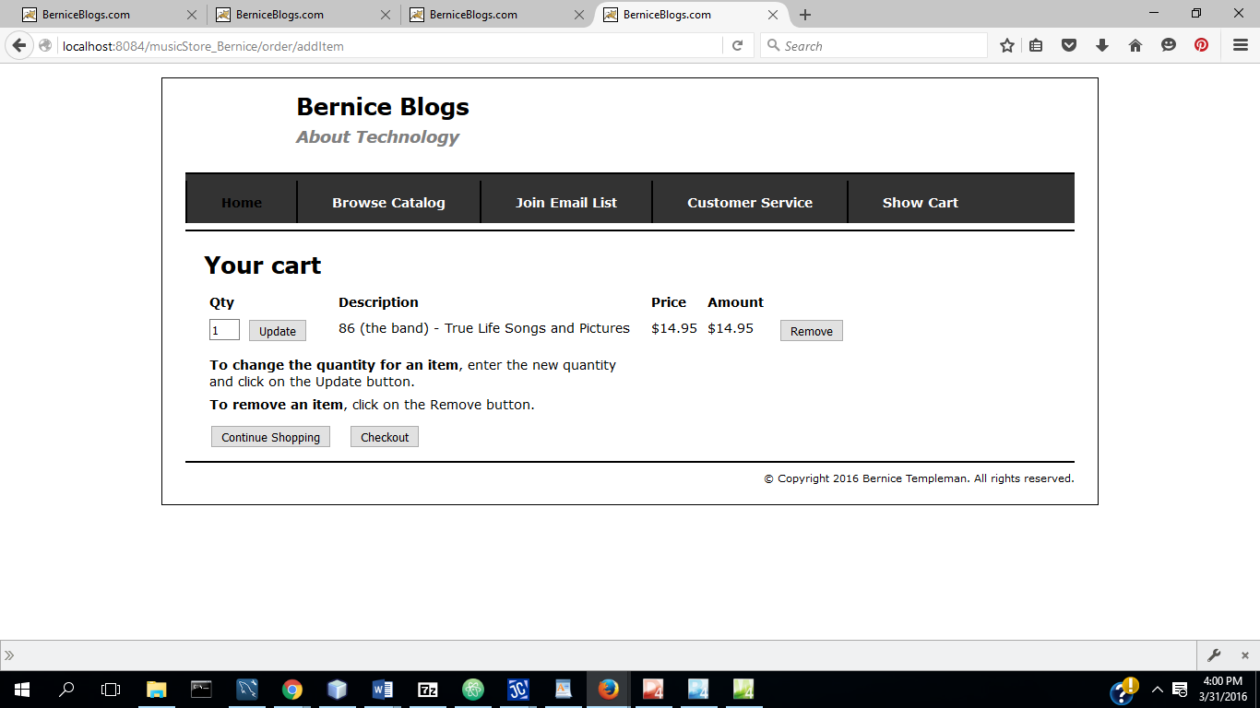

1. Listen to samples (using Music store for prototype)

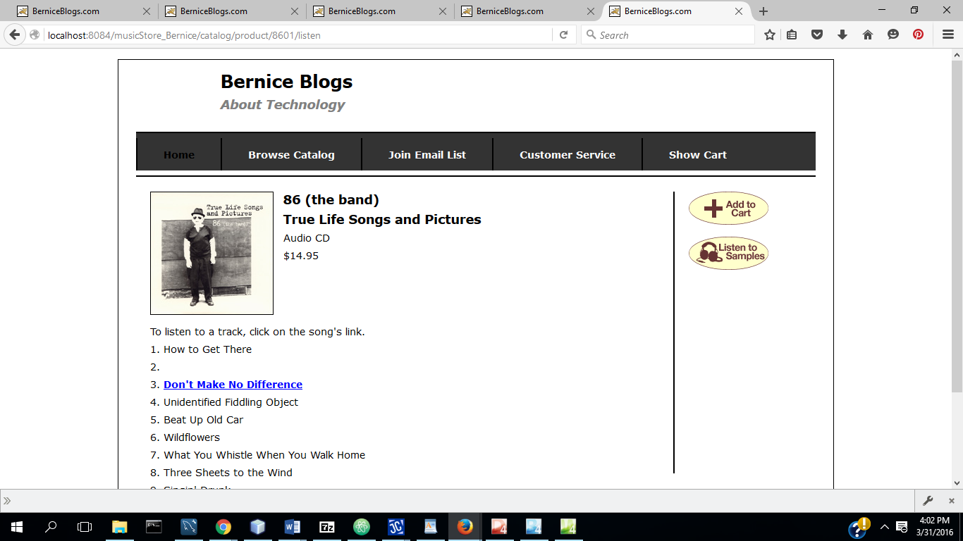

Checkout:

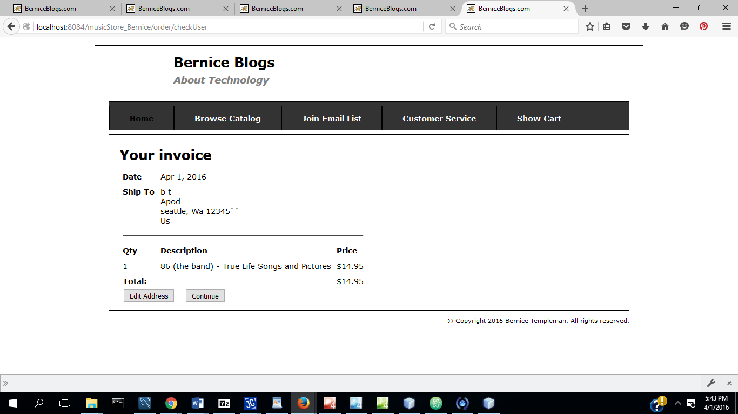

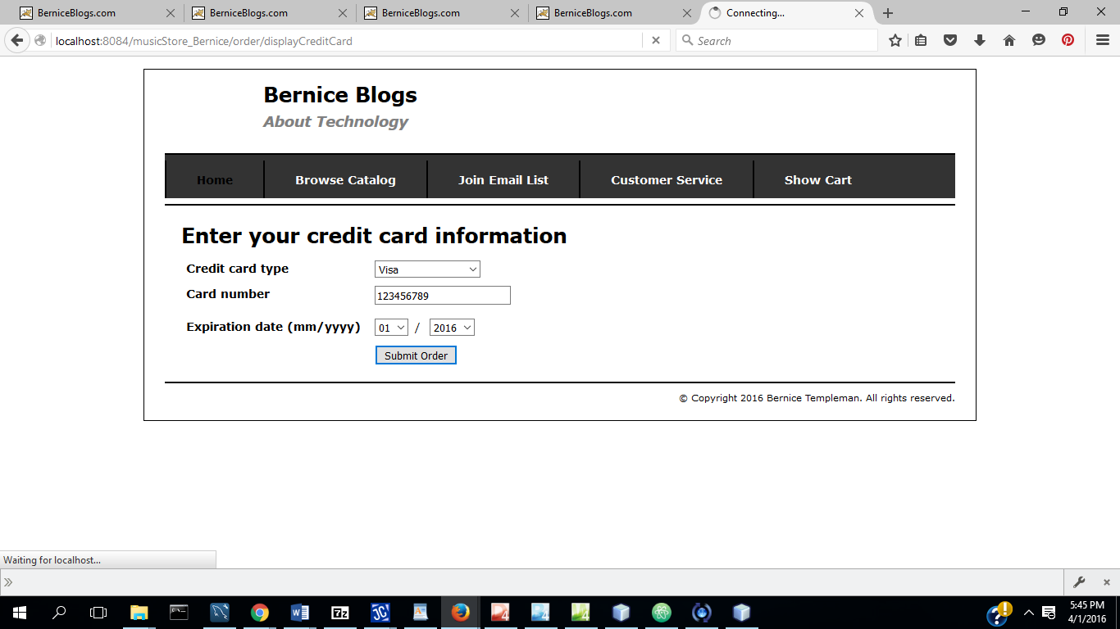

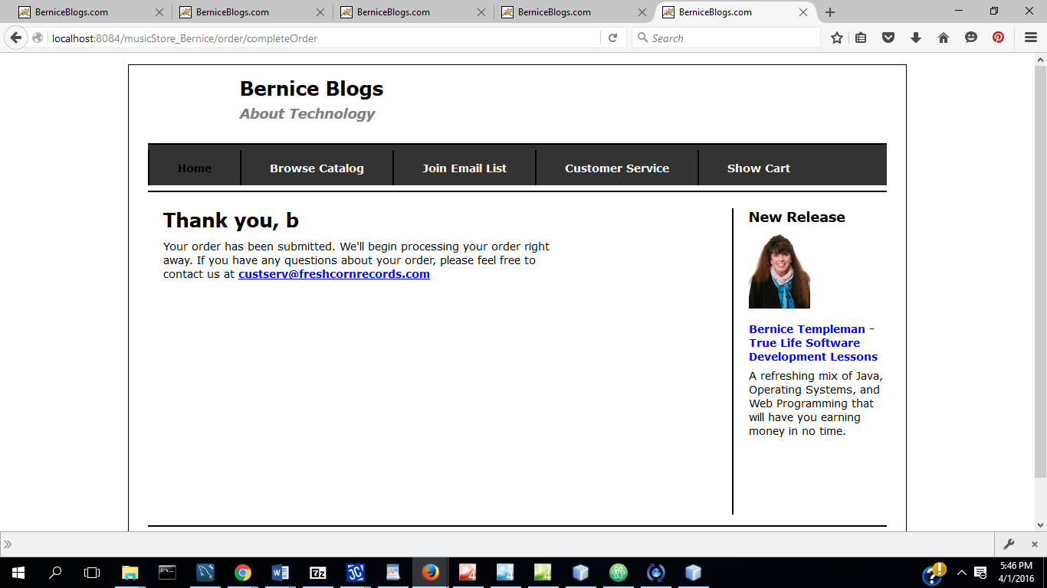

Bernice Templeman

CIS 5740/ Spring 2016

D3: Test Cases

**T01: Browse Catalog**

S01: Display Home Page

S02: Select Browse

S03: Select Product

S04: Select Add to Cart

S05: Select Continue Shopping

**T02: Join Email List**

S01: Display Home Page

S02: Select Join

S03: Enter information

S04: Select Submit

**T03: View Cart**

S01: Display Home Page

S02: Select View Cart

S03: Select Update Cart

S04: Select Delete Product

S05: Select Continue Shopping

S06: Select View Cart

S07: Select Checkout

**T04: Purchase**

S01: Invoice displayed

S02: Edit Address

S03: Select Continue

S04: Enter Credit Card Information

S05: Select Submit Order

S06: Thank You Page Displayed

**T05: Authenticate User**

S01: Display Login Screen

S02: Input User Id

S03: Input password

S04: check userid

S05: check password